The Official Publication of ALOA—An International Association of Security Professionals

Hurricane

Katrina

Follow-Up

PLUS!

Greg Perry on How To Handle a “Major”

HLOH 2007 Elections! and More!

*************%*****3_jjfQyY 203

BRECKH. CAMPCML PO BOX 47070 ATLANTA GA 30362-0070

**IiiIIiIIiu.iIIi.IIiiiiIiIIIiiiIIiiiIiiiIIIiiiIiiiIIIiiiiiIiII**

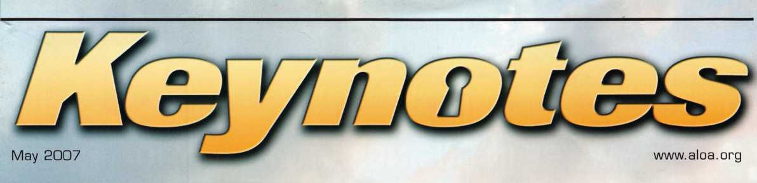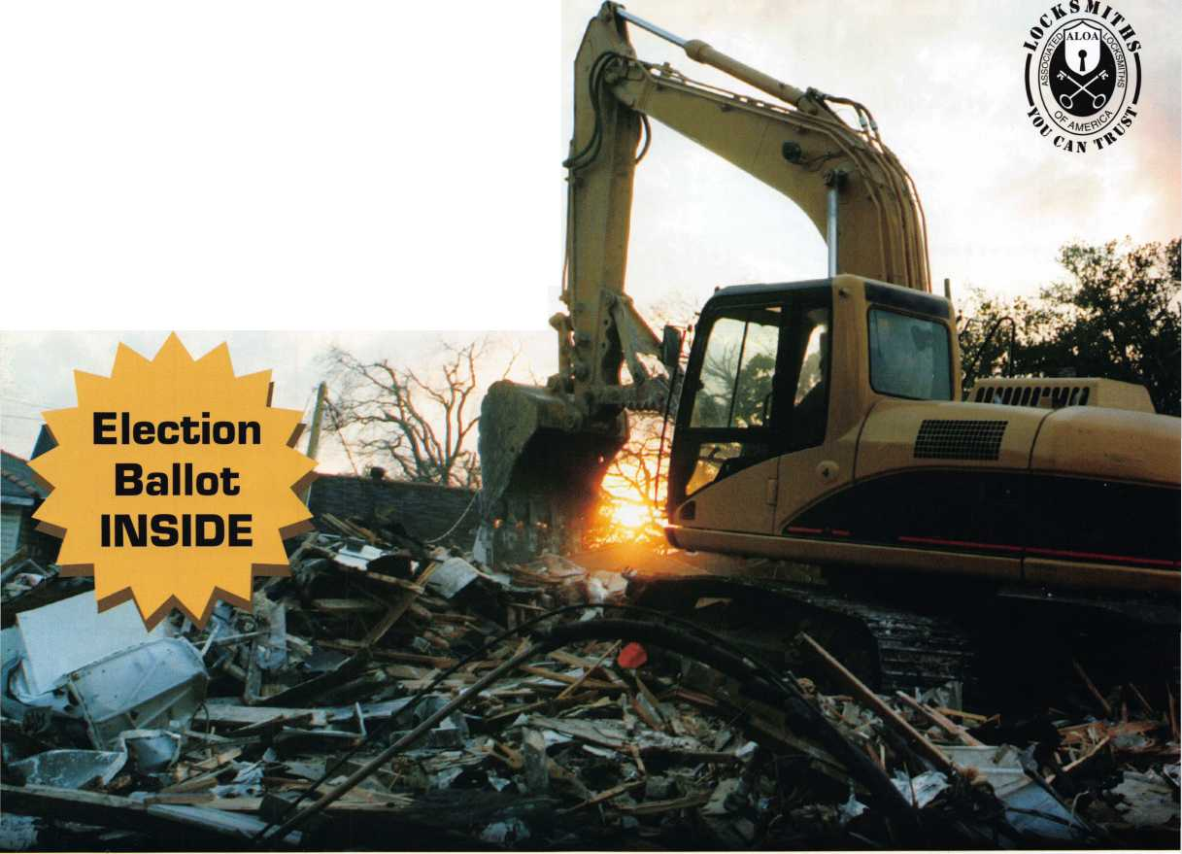

OUR STAND

**WE’RE IN BUSINESS TO HELP YOU**

**REDUCE DOWNTIME**

Commercial vehicle insurance designed to help you get back on the road.

When your vehicle is out of business, so are commercial vehicle insurance as well as other you. That's why A Istate provides fast and fair insurance products designed to help keep your

claim service. Your local Allstate agent offers business in the race. Are you in Good Hands®?

CALL NOW TO SPEAK TO AN ALLSTATE AGENT NEAR YOU

**Allstate**

***NASCAR***

**Subject to availability and qualifications. Allstate insurance Company and Allstate Indemnity Company, Northbrook, IL. Allstate County Mutual Insurance Company, Irving, TX. Allstate New Jersey Insurance Company, Bridgewater, NJ. The "Cupped Hands" logo is a registered service mark and "Our Stand" is a service mark of Allstate Insurance Company. NASCAR15' is a registered trademark of the National Association for Stock Car Auto Racing, Inc. © 2007 Allstate Insurance Company, Northbrook, IL.**

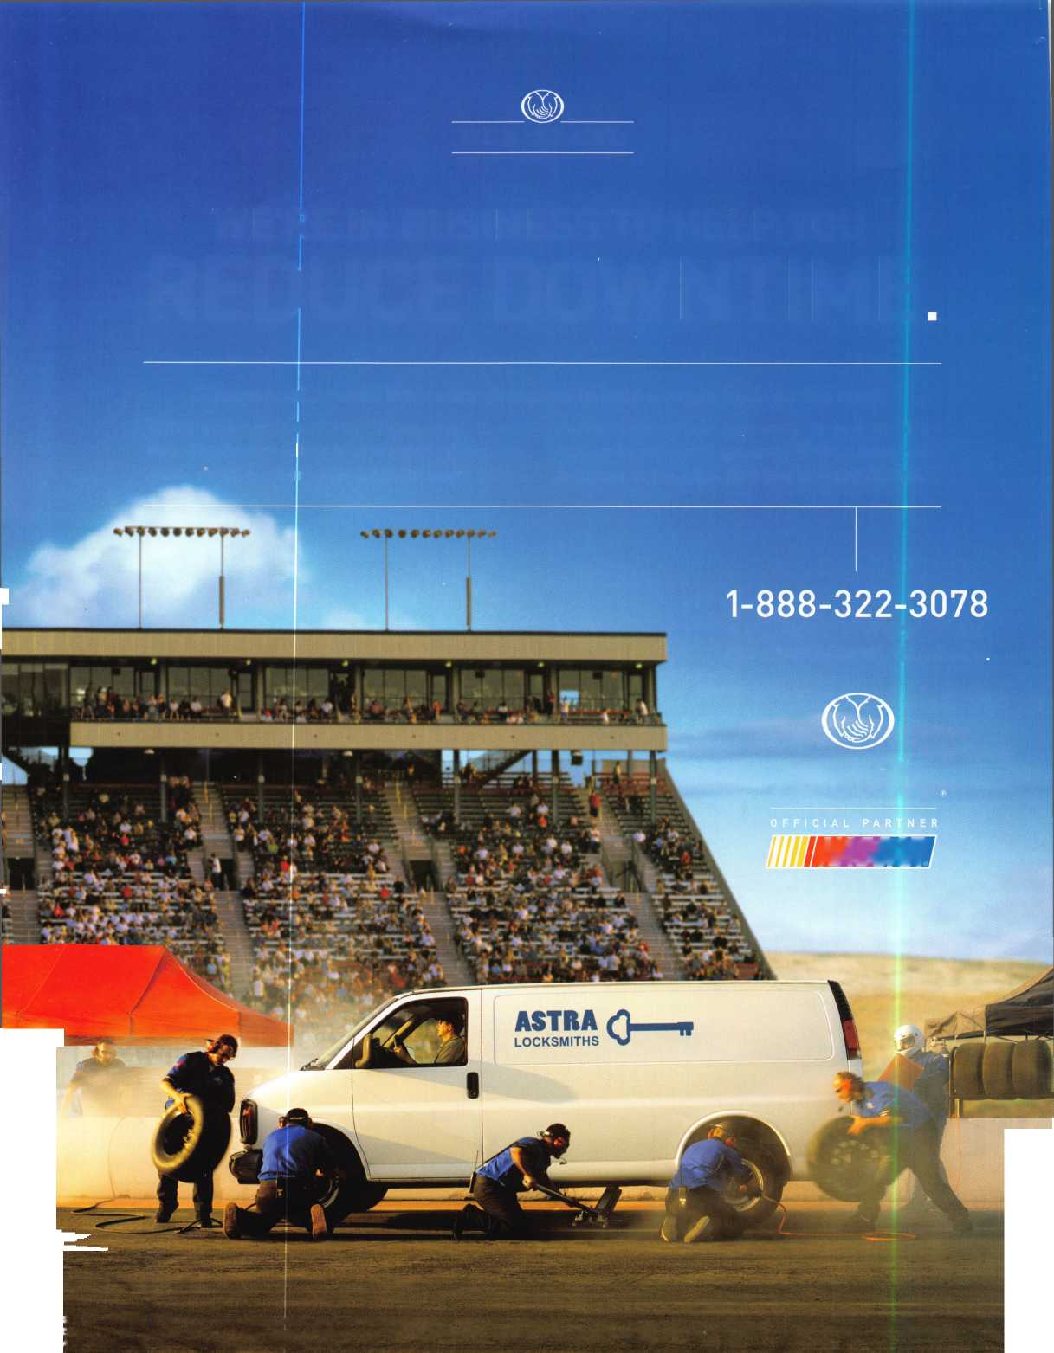

i



>'

A Name You Know

As a business owner, you know the importance of a  
good name. Your name is your reputation. Your name  
stands for all that you offer in products and services.  
It’s a symbol of who you are. So, we thought you  
might like to know that Allstate, the name you know  
for insuring your personal vehicle and your home,  
also offers a business auto policy to help protect vehi-  
cles used in your locksmith business.

The following are coverages typically included in  
our business auto policy that might be important to  
you as a business owner:

Business Auto Liability coverage

* Higher limits up to $2,000,000 per occur-  
  rence.
* Protects you if you are legally responsible  
  for injuries and damages arising out of  
  the ownership, maintenance, or use of  
  business vehicles.
* Cost is based on several factors, includ-  
  ing garage location, type and use of vehi-  
  cle, and the violation and accident activi-  
  ty of your drivers.
* Additional Insured coverage may be  
  required when you contract with govern-  
  mental agencies or bid on local  
  commercial jobs.
* Generally not available on a personal  
  auto policy.
* Usually is no charge to add an insured to  
  a Commercial Auto policy.

Hired Auto coverage

* Provides liability coverage for those  
  vehicles you rent, hire or borrow for  
  business use.
* The premium for hired auto liability  
  coverage is based on the estimated  
  annual rental cost.
* Tools and Special Equipment
* Provides protection to permanently  
  attached equipment on your vehicle.
* You will need to let your agent know the  
  value of the equipment to include in the  
  cost of the vehicle.

You’re good at your business. Your insurance com-  
pany should be the same way.

Contact an Allstate agent to discuss your business  
auto insurance needs. To be referred to an agent,  
please call 800.859.0247 or email  
[abisO@allstate.com](mailto:abisO@allstate.com).

Subject to availability and qualifications. Insurance coverage is  
subject to policy terms.

Allstate Insurance Company

Allstate Indemnity Company  
Northbrook, IL

Allstate County Mutual Insurance Company  
Irving, TX

Allstate New Jersey Insurance Company  
Bridgewater, NJ

allstate.com

© 2005 Allstate Insurance Company, Northbrook, IL

Need information in a hurry?

Use AIMS Fax On Demand service.

Just call 310-575-5027 and receive:

1. ALOA Index of Documents (1 pg)
2. Reasons to Join ALOA (2 pg)
3. Locksmith Career Summary (3 pgs)
4. Locksmith School List (1 pg)
5. ACE Class Schedule (1 pg)
6. Certification Information (5 pgs)
7. PRP Category List (1 pg)
8. ALOA Membership Application (1 pg)
9. ALOA List of Benefits (1 pg)
10. ASF Scholarship Application (1 pg)
11. ASF Scholarship Information (1 pg)
12. ALOA Video Library Order Form (1 pg)
13. Safe & Vault Technicians Association Membership

Application/Subscription Form (2 pgs)

1. Recertification Information (4 pgs)
2. Legislation Action Network Newsletter (2 pgs)
3. Various State Law Issues (8 pgs)
4. Industry Position Paper (1 pg)
5. ALOA Convention Class Schedule (3 pgs)
6. ALOA Convention Class Descriptions (30 pgs)
7. ALOA Convention Registration Forms (4 pgs)
8. Board of Directors Nomination Form (2 pgs)
9. ALOA Company Membership Application (2 pgs)

310-575-5027

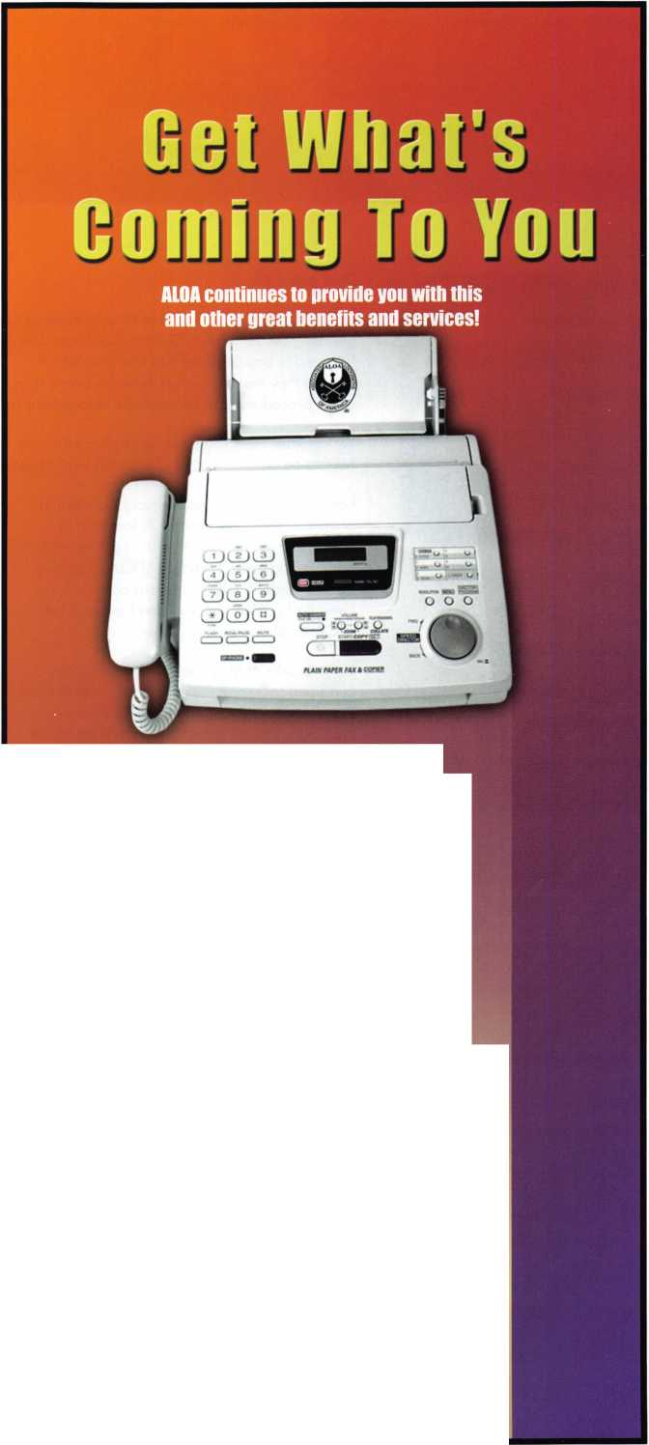

presidential

viewpoint

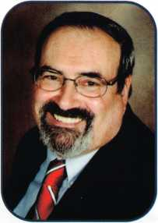

Dear Members,

This past month, your Board of Directors had its Spring Meeting in Phoenix; the meeting was held over Saturday and  
Sunday. The new Policy Governance Class was reviewed. This is a two day class required for all new board mem-  
bers and is broken down into four units which can be taken separately. Of course, anyone can take all or part of the  
class, if they want to explore how the board operates, or even glean new ideas for their chapter or affiliate. Many  
of the procedures can benefit local associations across the spectrum.

Yet, another item, the board was pleased to see, was the strategic plan for increasing our membership and mem-  
bership recognition. Most of this plan was presented by Ellen McEwen, our newest staff member in the Dallas office.

I attended the Fiftieth Anniversary Convention  
of the California Locksmiths' Association in  
Long Beach at the end of April. I presented to  
John Brueggeman, President of CLA, a plaque  
commemorating this momentous occasion.

Greg Parks, Ellen McEwen and I manned the  
ALOA booth for the busy show.

In the middle of May, I will be attending the  
European Locksmith Federation's Convention in  
Riga, Latvia. While I am there, I will attend  
ELF's board meeting and present a short report  
on the state of locksmithing in the states. Our  
Executive Director, Bill Gibson, will be in China  
attending the Fifth Anniversary of the China  
Locksmith Association. Then in June, I will be at  
the headquarters on the 8th for the special elec-  
tion meeting and review the final checklist for  
our convention in July.

In closing...Be a life-long student. Strive to learn something new every day. By this I mean, any new something, not  
just locksmithing. By exercising our minds, we make them strong. By exercising our volunteering spirit, our associa-  
tions become stronger. Don't forget to pay homage by VOTING for those who are volunteering to serve our associ-  
ation. Their strength and determination will carry ALOA onward and upward.

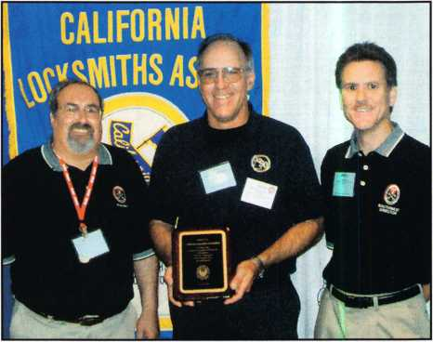

U

r.:

4

Take 'er easy! Sincerely,

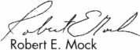

Keynotes • May 2007

SAFES MANUFACTURER

We sell directly to locksmiths - no middle man  
Most competetive pricing in the market  
Special incentive for new dealers  
Free freight available on East Coast*

Call us at 877-PROMET1 or 860-436-6246 Download our catalog from [www.promet-safe.com](http://www.promet-safe.com) Visit us at ALOA’07 Show, booth #143

* - subject to conditions

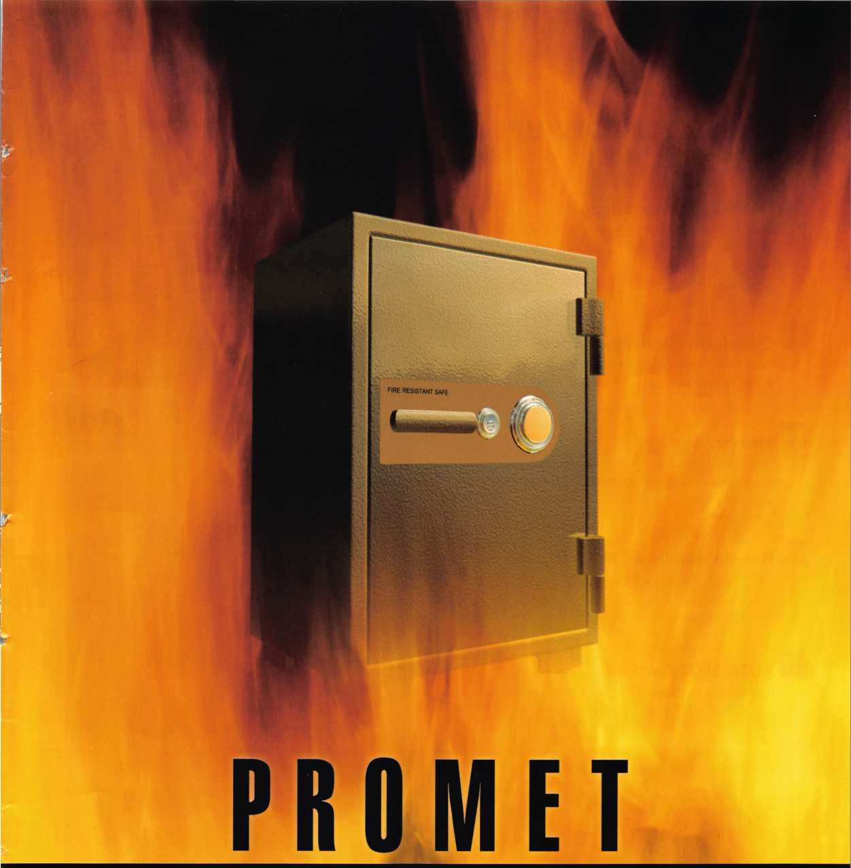

**feat**

KATRINA FOLLOW-UP

10

Like the Phoenix Rising

One year ago Jim made the trip to the Golf Coast to survey the damage to his hometown. See what has changed today.

by Jim Hancock

**14**

Cyberlock: Surviving Katrina

Read how Cyberlock electronic lock cylinders were put to an extreme test during Hurricane Katrina.

**16**

Member Survey

Here's our chance to influence changes within the Associated Locksmiths of America. Complete the sur­vey and win!

22

How to Handle a "Major"

Greg Perry shows you how you can handle a Major Safe.

by Greg Perry% CML, CPS

**28**

ALOA 2007 Elections

It's that time of year again. Don't forget to vote!

**u r e s**

|  |  |  |
| --- | --- | --- |
| r |  |  |
| AD INDEX | |  |
| Allstate | Inside Front Cover |  |
| Fax on Demand | 1 |  |
| Promet | 3 |  |
| ALOA 2007 | 7 |  |
| American Security Products . | ii |  |
| Videx | 15 |  |
| Ben Jim | 17 |  |
| Inkas | 19 |  |
| IR | 21 |  |
| Turn 10 | 23 |  |
| Clearstar | 24 |  |
| A&B | 25 |  |
| Bianchi | 27 |  |
| ALOA Member Recruitment | 32 |  |
| Ultralift | 33 |  |
| Locksmithing UNL | 40 |  |
| A&B | 40 |  |
| Coast Safe & Lock | 40 |  |
| PBP | 40 |  |
| HL Flake | 41 |  |
| ALOA President's Club | 42 |  |
| SAFETECH 2008 | 43 |  |
| LetroTruck | 43 |  |
| Jet Hardware | 44 |  |
| Door Jam Armor | ..Inside Back Cover |  |
| CCL | Back Cover |  |
| L |  |  |

**Departments**

|  |  |  |  |  |  |  |  |  |
| --- | --- | --- | --- | --- | --- | --- | --- | --- |
| Presidential |  | Executive | 5 | Calendar | 8 | Classified | 34 | Legislative 38 |
| Viewpoint | 2 | Applicants .... | 6 | Core | 9 | Associate Members | 36 |
|  |

Visit our NEW website at [www.aloa.org](http://www.aloa.org)

executive

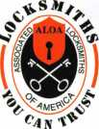

Volume 53, Issue 5

Additional contact information for the ALOA Board is available on the ALOA website—  
[www.aloa.org](http://www.aloa.org) or by contacting the ALOA office at 3500 Easy Street; Dallas, TX 75247;  
(800)532-2562; FAX (214)819-9736; e-mail [aloa@aloa.org](mailto:aloa@aloa.org).

Editor & Director of Creative Services Comptroller

|  |  |  |  |
| --- | --- | --- | --- |
| Betty Southerland | [betty@aloa.org](mailto:betty@aloa.org) | Kathy Romo | [kathy@aloa.org](mailto:kathy@aloa.org) |
| Advertising Sales |  | Membership Development Manager | |
| Kim Hammond | voice: 817-645-6778 | Ellen R. McEwen | [ellen@aloa.org](mailto:ellen@aloa.org) |
|  | Fax: 817-645-7599 |  |  |
|  | e-mail: [adsales@aloa.org](mailto:adsales@aloa.org) | Membership Coordinator | Shelly Jett |
| Executive Director |  | Convention & Meetings Assistant Karen Lyons | |
| Charles W. Gibson, Jr., CAE | [charlie@aloa.org](mailto:charlie@aloa.org) |  |  |
|  | PRP/Education Coordinator Shelley Melton | |
| Associate Executive Director | |  |  |
| David Lowell, CML, CMST | [david@aloa.org](mailto:david@aloa.org) | Mail Room Coordinator | Kevin Wesley |
| Convention & Meetings Manager | | Graphic Designer | Margarita Garza |
| Jo Anne Mims | [joanne@aloa.org](mailto:joanne@aloa.org) | Accounting Coordinator | Joyce Nixon |
| Operations/Membership Manager | | Executive Assistant | Sue Langford |
| Mary May | [mary@aloa.org](mailto:mary@aloa.org) |
| Director of IT Operations |  | Assistant Education Manager Bob Stafford, CML | |
| Greg K. Jackson | [greg@aloa.org](mailto:greg@aloa.org) | Legislative Manager |  |
| Tim McMullen |
| Contributors |  |  |  |
| Jerome Andrews, CML | Ray D'Adamo, CML | Randy Simpson, CML, CPP | Tom Seroogy |
| Paul Chandler, CRL | Billy Edwards, CML | Robert Stafford, CML | Charles Stephenson, CPS |
| Claire Cohen, CML | Dan Graffeo, CRL,CMST | Dave Thielen, CML | Dennis Watanabe, CML, CMST |
| Brian Costley, CML, CMST | Jim Hancock, CPL | Greg Perry, CML,CPS |  |
| Eric Costley, CRL | Jeff Nunberg, CML, CMST |  |  |

Mission Statement: The Associated Locksmiths of America, Inc. is dedicated to enhancing the professionalism, education and ethics among  
locksmiths and those in related sectors of the physical security industry. With approximately 10,000 members in the United States, Canada and the  
freeworld, ALOA is poised to help members obtain the knowledge, the strength, and the confidence to perform their role in the physical security field  
with pride and dignity. But it is only through active involvement and participation that ALOA can fully achieve its potential—and can help members to  
achieve theirs.

Policies: Keynotes® is the official publication of the Associated Locksmiths of America, Inc. (ALOA). Keynotes® acts as a moderator without approving,  
disapproving, or guaranteeing the validity or accuracy of any data, claim, or opinion appearing under a byline or obtained or quoted from an acknowl-  
edged source. The opinions expressed by the authors do not necessarily reflect the official views of ALOA. Also, appearance of advertisements and  
new products or service information does not constitute an endorsement of products or services featured by the Association. The Association does not  
accept responsibility for the inaccuracy of any data, claim, or opinion appearing in this publication, due to typographical errors on the part of the  
authors, Association staff or its agents.

Editor's Note: This publication is designed to provide accurate and authoritative information in regard to the subject matter covered. It is provided  
and disseminated with the understanding that the publisher is not engaged in rendering legal or other professional services. If legal advice and other  
expert assistance is required, the services of a competent professional should be sought.

Authors' Payment: Payment for eligible submissions to Keynotes will be based on the following criteria: topic, time spent and past contributions. Authors who  
regularly submit to Keynotes® are generally paid a higher rate. The latter is especially true of authors who write to fit specific editorial needs and submit said copy  
by Keynotes® deadlines. As a general guideline: Average payment for a 750 word, business or light' technical article would be $200. Payment for a 1500 word  
article involving significantly higher time and research efforts would be $400.

Payment will not be offered for articles submitted by ALOA employees or members of the ALOA Board of Directors (unless material is of a technical  
nature), nor for articles submitted by a company that promote that company's products or services. ALOA reserves the right not to pay for articles sub-  
mitted by an individual(s) that promote a particular company's products or services.

Disclaimer: The Associated Locksmiths of America, Inc., (ALOA), reserves the right to refuse any article for any reason. Additionally, ALOA reserves  
the right to edit, amend or modify any article submitted for publication in order to preserve technical accuracy, clarity, fairness or grammatical correct-  
ness. ALOA will make the best efforts to notify the author of any changes. The extent of ALOA's liability for any article or information contained there-  
in will be a notice of correction or retraction in the next possible issue.

Keynotes® (ISSN 0277 0792) is published monthly except for the combined June/July issue by The Associated Locksmiths of America, Inc.,  
3500 Easy St., Dallas, TX 75247-6416. Telephone: (214) 819-9733; FAX (214) 819-9736; e-mail [aloa@aloa.org](mailto:aloa@aloa.org). Subscription rates for  
members—$15.00 per year. Periodical class postage paid at Dallas, Texas. POSTMASTER: Send address changes to: Keynotes, 3500 Easy St., Dallas,  
TX 75247-6416. © Copyright 2003, All rights reserved. No part of the contents may be reproduced or reprinted in any form without prior  
written permission of the publisher.

President

Robert Mock  
(856) 863-0710  
presiden@aloa. org

Secretary

John Soderland, CML, CMST  
(414) 327-5625  
$ecretary@aloa .org

Directors, Northeast

Tom Foxweil  
(410) 206-5772  
[nedirector@aloa.org](mailto:nedirector@aloa.org)

Robert D. DeWeese, CML, CPS  
(410) 285-0101  
nedirector@aloa. org

Directors, Southeast

Tom Gillingham, Jr., CML, CPS  
(615) 264-0747  
sedirector@aloa .org  
Ken Kupferman, CML, CPS  
(813) 232-7600  
sedi rector@aloa. org

Director, North Central

William Smith, RL  
(920) 893-5282

Guy Spinello, RL  
(815) 394-1000

ncdi rector@aloa. org

Director, South Central

CD Lipscomb, CML, CPS  
(903) 874-3522  
scd irecfor@dloa .org

Directors, Southwest

Greg Parks, CRL  
(858) 271-1155  
[swdirector@aloa.org](mailto:swdirector@aloa.org)

Julie McCluney, CRL  
(714) 636-5652  
swdirector@aioa .org

Director, Northwest

Keith E. Whiting, CML, CFL  
(360) 601-5656  
n wd i rector@a loa. org

Director, International

Hans Me|lshede, CML  
(453) 539-3939  
surdirector@aloa .org

Director, Associate

Dan Floeck  
(800) 231-4105  
asd i rector@aloa. org

Trustees

[trustees@aloa.org](mailto:trustees@aloa.org)

Randy Simpson, CML, CPP  
(281) 240-5959

JohnJ. Greenan, CML, CPS  
(773) 486.2030

William Young, CML, CPS  
(610) 647-5042

Past Presidents

2003-2005 William Young, CML, CPS  
2001-2003 Randy Simpson, CML  
1999-2001 John Greenan, CML, CPS  
1997-1999 Dallas C. Brooks  
1995-1997 David Lowell, CML, CMST  
1993-1995 Breck Camp, CML  
1991-1993 Henry Printz, CML  
1989-1991 Evelyn Wersonick, CML, CPS  
1987-1989 Leonard Passarelio, CPL  
1985-1987 Joe Jackman, CML  
1983-1985 Stanley Haney, CPL  
1981-1983 Louis LaGreco, CPL  
1979-1981 John Kerr, RL  
1977-1979 Clifford Cox, CML  
1974-1977 Charles Hetherington  
1972-1974 Gene Laughridge  
1970-1972 William Dutcher, RL  
1968-1970 Constant Maffey, RL  
1966-1968 Harold Edelstein, RL  
1964-1966 William Meacham  
1962-1964 Robert Rackliffe, CPL  
1960-1962 Edwin Toepfer, RL  
1956-1960 Ernest Johannesen

Keynotes • May 2007

AL

NJ

Wichita Falls

Decatur

Charles D. Sherman CPL

AZ

Tempe

Lars Ambrose

Sponsor: Patricia Lee

CA

Pinedale

Kathleen Ramirez

Sponsor: Lisa M. Guzman Santa Ana

Robert Baker

CO

Broomfield

Louis R. Spallone CPS

Pillion

Joseph A. Jefferson

Sponsor: Julio L. Machado

DC

Washington

Biniyam Geremew

Sponsor: Philip A. Rovenolt CPL

FL

Apopka

Jason Gage

Sponsor: Mark S. Crews Davenport

Arthur Brown

Sponsor: Michael S. Adams Hollywood

Eric A. Seymour

Leesburg

David B. Kessler

Tampa

Anthony Ruperto

Sponsor: Sid E. Rose

*GA*

Atlanta

Burton Kolker Ariel Shtauber

Hampton

Wayland P. Keller

Warwick

James L. Wedges

Sponsor: Danny W. Rudd CPL

IL

Glen Carbon

Alan L. Crews

MD

Montgomery Village

John L. Norvell

Sponsor: Michael B. Groves

Ml

Redford

Randy Vance

NC

Kitty Hawk

Colin M. Noone

Nags Head

Joseph R. Campbell Michael B. Clarkin

ND

Bismarck

Matt P. Brendel

Sponsor: William K. Ortmann CPL Fargo

Robert E. Ruud

Sponsor: Todd K. Ladwig CML,

Christopher S. Chapman

Sponsor: Todd K. Ladwig CML

Erik J. Harmon

Sponsor: Todd K. Ladwig CML,

NE

Lincoln

Josh Seybert

Sponsor: John L. Firestine

Blackwood

Gary Flint

Sponsor: Shane M. Varney CRL, Hackensack

Michael D. Glasser CRL

NV

Silver Springs

Kim Robinson

Sponsor: Brian M. Saffran CRL

Mahopac

Brian J. Lena

OH

Cleveland

Ofer Buskila

Sponsor: Emir Y. Abeid RL Oakwood Village

Stanley C. Davis

Sponsor: John R. Hilinski

PA

Cranberry Township

Paul Christiana

Sponsor: Anthony E. DeMino

SC

Florence

LaRue Medlin

Sponsor: Alonzo M. Hill

TN

Knoxville

Drew Williams

Sponsor: Curtis L. Clanton Woodbury

Alfred J. Breau

TX

Richardson

Eyal Riffer

Spring

Adrian Dedominicis

David C. Matlock

Sponsor: Clifford D. Lipscomb CML, CPS

VA

Big Stone Gap

Paul Floyd

Sponsor: Thomas Dickenson Rocky Mount

Kevin T. Hunley

VT

Sutton

Dennis Y. Parent

Sponsor: James G. Harper

WA

Mountlake Terrace

Christopher Weissman

Sponsor: Barry L. Weissman Olympia

Nicholas L. Gilbert

Sponsor: Owen F. O'Keefe CPL Spokane

Jay Stiles

Sponsor: Kevin Morrisey

Wl

Fremont

John D. Lister

Sponsor: John F. Engel CRL

WY

Cheyenne

William W. Halle IV, RL



London

Fergal Donoghue

Sponsor: Ken Dale Borehamwood

Allen Isaacs

Guam

Barrigada

Jaime Benavente

These applicants are scheduled for clearance as members of ALOA. The names are published for member review and comment within 30 days of this Keynotes issue date, respectively, to ensure applicants meet standards of  
ALOAs Code of Ethics. Protests, if any, should be addressed to the Membership Department and must be signed. Active Membership applicants (a) have worked in the industry two or more years. Allied Membership (AL)  
applicants are not locksmiths, but work in a security-related field. Apprentice Membership (AP) applicants have worked in the industry less than two years.



Keynotes • May 2007



Start Your Engines!

This year, with a great location and a  
schedule chock-full of exciting classes  
and events, we are pulling out all the  
stops to celebrate the ALOA Convention  
and Security Expo in Charlotte, North  
Carolina.

Having built an international reputation  
among locksmiths as a powerful resource  
to explore industry innovation and form  
industry alliances, ALOA 2007 is the ideal  
place to learn, network or to showcase  
your security-related business on the  
show floor.

This year weve thought of everything  
from an exciting location to a comfort-  
able hotel and a convention center that is  
equipped to handle your every need. The  
exhibit hall promises to be overflowing  
with the latest technology and new mer-  
chandise.



july 22-29, 2007

charlotte, north Carolina

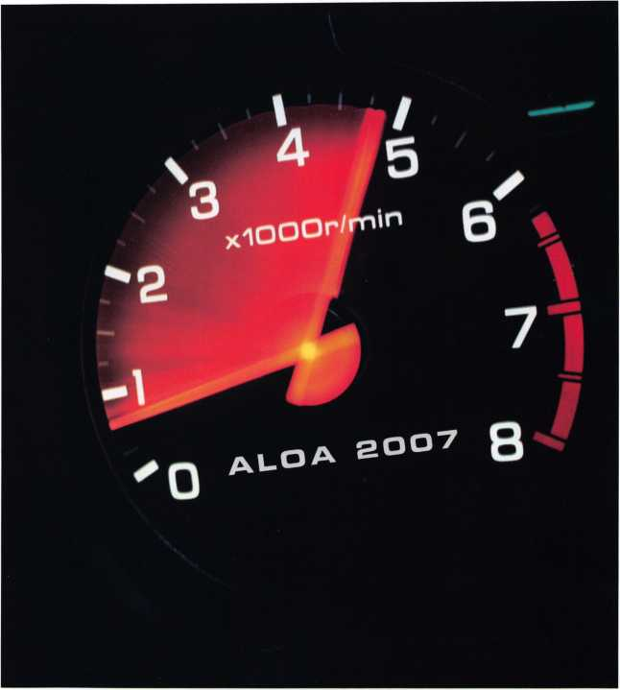

aloa convention and security expo

*51****st ANNUAL***

Don't miss out!

800-532-2562

upcoming events



|  |  |  |
| --- | --- | --- |
| 5/1 Counter Days • [www.doylesecurity.com](http://www.doylesecurity.com) | 5/4-6 Wyoming Locksmiths Assc. Trade Show | 5/18-20 ELF Convention 2007 • Riga, Latvia |
| 5/16 Doyle University | Casper, Wyoming | European Locksmith Federation |
| Minneapolis, MN | Jim O'Grady • 307-234-5932 | Exhibition - Social events -Education |
| Doyle Security Products |  | [www.elf2007.com](http://www.elf2007.com) • ruta.reinika@prplus.l |
| For more info [www.doylesecurity.com](http://www.doylesecurity.com) |  |  |

|  |  |  |  |
| --- | --- | --- | --- |
|  | | | |
| 6/6 Counter Days • Minneapolis, M Doyle Security Products  RCI with Mark Schrantz • [www.doylesecurity.com](http://www.doylesecurity.com) | N | 6/20 Doyle University  Minneapolis, MN  Doyle Security Products  For more info [www.doylesecurity.com](http://www.doylesecurity.com) | 6/23 VLA Meeting & Class  Charlottesville, VA  Contact: Elliot Paul Conner email: [va_locksmith@verizon.net](mailto:va_locksmith@verizon.net) |
| 7/22-29 ALOA '07 Convention & Security Expo Charlotte, NC  Associated Locksmiths of America [convention@aloa.org](mailto:convention@aloa.org) [www.aloa.org/](http://www.aloa.org/) convention | | 7/1 1 Counter Days • [www.doylesecurity.com](http://www.doylesecurity.com) |  |

July, August, and September t Classes will resume after the l

will be no Doyle University - iber Trade Show.

9/14-15

Doyle Annual Trade Show & Education • Prior Lake, MN Doyle Security Products Mystic Lake Casino [www.doylesecurity.com](http://www.doylesecurity.com)

**UPCOMING ACE CLASSES**

May 5, 2007

May 7- 12, 2007

May 14- 17, 2007

May 17-19, 2007

June 14-15, 2007

June 16-17, 2007

June 22-24, 2007

July 14, 2007 July 14, 2007 July 22-29, 2007

August 20-25, 2007

August 24-25, 2007

September 5-8, 2007

September 11-15, 2007

Roseville, Michigan • Locksmiths Security Association

Small Format 1C w/L-38 PRP

Marc A. Dearing, CRL • 810-2444038

Dallas, Texas • ALOA Training Center

Six-Day Basic Locksmithing Course

ALOA Education • [education@aloa.org](mailto:education@aloa.org)

800-532-2562x104

Seattle, Washington • KDL Hardware Show

Basic, Intermediate and Advanced classes available

For more info contact: Julie Pilgrim, 800-926-7716

Dallas, Texas • ALOA Training Center

3-Day Automotive Locksmith Course

ALOA Education • [education@aloa.org](mailto:education@aloa.org)

800-532-2562x104

Reno, Nevada • Clark Security Products

Basic Safe Lock Servicing, Transponder Technology

Joan Emrick • 858-9746737

Birmingham, Alabama • Alabama Chapter of ALOA

Basic Electricity & Electronics w/L-13 PRP

Installing & Servicing Access Control

Dallas Brooks • 334-826-8990

Ft.Wayne, Indiana • Northern Indiana Chptr of ALOA

PRP Exam, Domestic Auto w/L-03 PRP, Foreign Auto w/L-04 PRP

Jeremy Rodocker CML, CPS • [rodockers@hotmail.com](mailto:rodockers@hotmail.com)

260459-1500

Kansas City, Missouri • Missouri-Kansas Locksmith Association

Transponders the Complete Story

Bob Turner • 816-525-5522

Norfolk, Nebraska • Nebraska Chapter of ALOA

Advanced Topics in Master Keying w/L-31 PRP

Elmer Howard • [safeman@cox.net](mailto:safeman@cox.net) • 402-676-8973

Charlotte, North Carolina

ALOA 51 st Annual Convention & Security Expo

70 Full Day Classes • 35 Half Day Classes

& Evening Seminars • ALOA Education • [education@aloa.org](mailto:education@aloa.org)

800-532-2562x101 • [www.aloa.org](http://www.aloa.org)

Dallas, Texas • ALOA Training Center

Six-Day Basic Locksmithing Course

ALOA Education • [education@aloa.org](mailto:education@aloa.org)

800-532-2562x104

Montgomery, Alabama • Alabama Chapter of ALOA Exit Devices & Exit Alarms w/L-16 PRP Complete Door & Door Closers w/L-05 PRP Dallas Brooks • 334-826-8990 Dallas, Texas • ALOA Training Center Four-Day Time Lock Servicing Course ALOA Education • [education@aloa.org](mailto:education@aloa.org) 800-532-2562x104

Anaheim, California • Clark Security Products Safe Lock Manipulation, Safe Lock Servicing,

Transponder Servicing • Joan Emrick • 858-9746737

September 14-15, 2007

September 15, 2007

September 19-21, 2007

Minneapolis, MN • Doyle Security Show For a complete listing contact:

Kristina Larsen • 612-521-6226 • [www.doylesecurity.com](http://www.doylesecurity.com)

Roseville, MN • Locksmiths Security Association

Intermediate Auto Lock Servicing w/L-03 PRP

Marc A. Dearing, CRL • 810-244-4038/[mkdearing@comcast.net](mailto:mkdearing@comcast.net)

Sturbridge, MA • Yankee Security Convention

For a complete listing contact: Stephen McKinney

800-209-8266 • [www.yankeesecurity.org](http://www.yankeesecurity.org)

**UPCOMING PRP Sittings**

5/6/07 Sunday 8:00am • Great Falls, MT • Fred Martin, CRL

Montana Chapter of ALOA • 406-642-3961

5/12/07 Saturday 1:00pm • Dallas, TX • ALOA Certification

ALOA Training Center • [education@aloa.org](mailto:education@aloa.org) 800-532-2562x104

5/19/07 Saturday 5:30pm • Seattle, WA • Julie Pilgrim

KDL Hardware Show • 800-926-7716

6/2/07 Saturday 9:00am • Largo, MD • Ed Korenge

Maryland Locksmith Association & NPALIPGCC [ed@lstinhardware.com](mailto:ed@lstinhardware.com) • 410-646-9900

6/5/07 Saturday 9:00am • Baltimore, MD • Ed Korenge

Maryland Locksmith Association • 410-646-9900 ed@l stinhardware.com

6/8/07 Friday 8:00am • Dallas, TX • ALOA Certification

ALOA Training Center • [education@aloa.org](mailto:education@aloa.org) 800-532-2562x104

6/17/07 Sunday 8:00am • Sparks, NV • Joan Emrick

Clark Security Products • [joan.emrick@clarksecurity.com](mailto:joan.emrick@clarksecurity.com) 858-974-6737

7/27/07 Friday 6:00pm • Charlotte, NC • ALOA Certification

ALOA 2007 Convention • [education@aloa.org](mailto:education@aloa.org) 800-532-2562x104

8/25/07 Saturday 1:00pm • Dallas, TX • ALOA Certification

ALOA Training Center • [education@aloa.org](mailto:education@aloa.org) 800-532-2562x104

9/14/07 Friday 8:00am • Dallas, TX • ALOA Certification

ALOA Training Center • [education@aloa.org](mailto:education@aloa.org) 800-532-2562x104

9/16/07 Sunday 8:00am • Anaheim, CA • Joan Emrick

Clark Security Products • [joan.emrick@clarksecurity.com](mailto:joan.emrick@clarksecurity.com) 858-974-6737

9/22/07 Saturday 9:00am • Sturbridge, MA • Steve McKinney

Yankee Security Convention • [info@yankeesecurity.org](mailto:info@yankeesecurity.org) 800-209-8266

9/23/07 Sunday 10:00am • Farmington, NM • 505-632-6641

Association Locksmiths of New Mexico Wayne Wilkins, CRL • [classicrez@yahoo.com](mailto:classicrez@yahoo.com)

**Contact the ALOA Education Department for a list of classes and training offered in-house.**

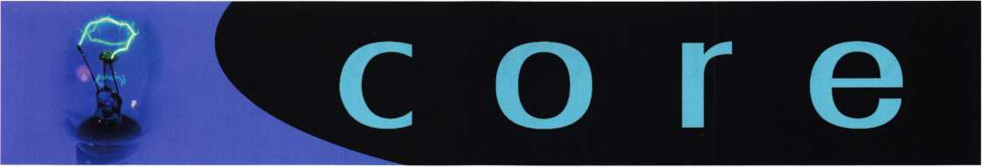

HOBOKEN LOCK WINS U.S.S. CONSTITUTION

MANNING THE TABLE

Al Van Alstyne, owner  
of Hoboken Lock on  
Washington Street, in  
Hoboken, NJ., won a $2,000  
replica of the U.S.S.  
Constitution as part of a sales  
promotion jointly sponsored by  
Accredited Lock of Secaucus,  
N.J. and CCL Security  
Products, Wheeling, IL, a divi-  
sion of The Eastern Company.

Each time Hoboken Lock picked up a shipment of CCL Security  
Products from Accredited Lock, they were eligible to deposit a num-  
bered ticket in a secure drop box at the CCL display in the Accredited  
Showroom. The U.S.S. Constitution replica was on display during the  
months ofFebruary and March, 2007.

The replica is a 1:60 scale model of the U.S.S. Constitution made  
from teak, mahogany, oak, rosewood and ash. It was handmade  
from scratch using original engineering drawings of the warship.

The Constitution is enclosed in a glass case to preserve its beauty.

Board Secretary Soderland was manning an ALOA table as a service to members attending the Clark Security Education event and trade show in Chicago. PRP exams were administered at the conclusion of the event, which is held annually in March.

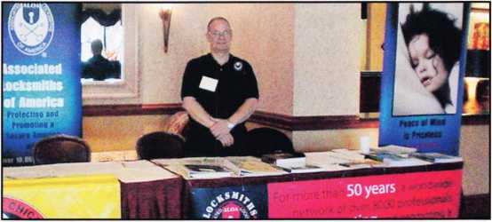

CLONE ENCRYPTED KEYS

The new JET SMART CLONE + CRYPTO UPDATE will now quickly duplicate all Texas Instruments (Tl) CRYPTO keys. All existing Jets Smart

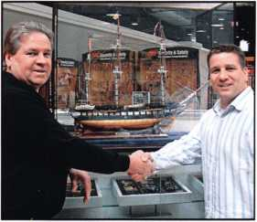

The U.S.S. Constitution was presented to Mr. Van Alstyne, by Ron  
Weaver, president and CEO, of Accredited Lock. After the presenta-  
tion, Weaver told Arthur Lefkowitz, CCL Representative in New Jersey,  
and the person who developed the promotion, that he was happy for  
Al Van Alstyne, but sorry to see the ship leave his display area. "It  
was one of the nicer promotions I have been associated with. A very  
unique prize which created a lot of attention."

The actual U.S.S. Constitution, also known as "Old Ironsides" was  
commissioned in 1794. The Frigate survives today at Boston Harbor  
and is open to the public. It sails the Boston Harbor every Fourth  
of July.

IN PASSING...

Steve Brown, CML, ALOA Member since 1978 and lifetime member  
of the Maryland Locksmiths Association passed away on March 17,  
2007. We will miss Steve and the positive energy he brought to the  
Locksmithing Industry. Even when he was sick with cancer he still  
found the time and energy to help the Maryland Locksmith Association

in many ways.

CONGRATULATIONS!

Charles W. Gibson, CAE,  
celebrated 15 years with  
the Associated Locksmiths of  
America. The Board of Directors  
celebrated this occassion with  
a cake and a thoughtful gift.

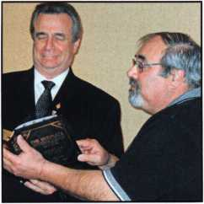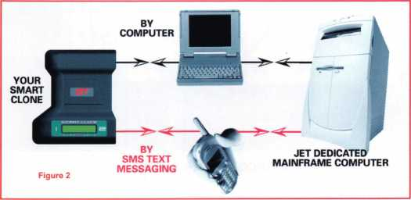

Clone machines can be immediately updated with the CRYPTO soft­ware package. There is no need to return the device to the factory for updating. Jet now offers the SCH-2 Transponder Key Bow with 10 blades covering over 100 of the most-popular Tl-encrypted system automobiles. This system uses a computer connected to the Internet or a Cell Phone with SMS TEXT messaging. Full details may be seen at: [www.jetkeys.com](http://www.jetkeys.com). Catalogs are available from your favorite Jet Distributor or by writing: Jet Hardware Mfg. Corp., 800 Hinsdale Street, Brooklyn, NY 1 1207.

NJMLA FLEA MARKET • JUNE 10, 2007 • 9a-lp

North Jersey Master Locksmith Association 13th Annual Locksmith flea market. Tables are available for $45. Buy, sell or trade. New or old; dead stock or overstock, they are all here. Each year there is a large selection of items including but not limited to: deadlocks, doorknobs, ic cores, panic bars, keyblanks, machines, books, manuals. You name it, we probably have it! For more info call Jeff Sitar (973) 777-0620 or Nick Hart(201) 944-7547.

Like the Phoenix Rising

by Jim Hancock, CPL

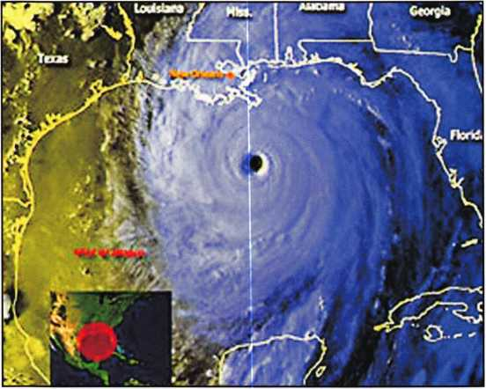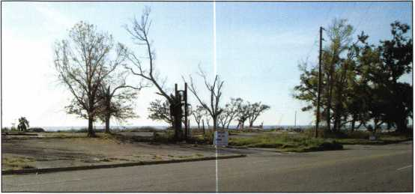

Hancock Lock & Key

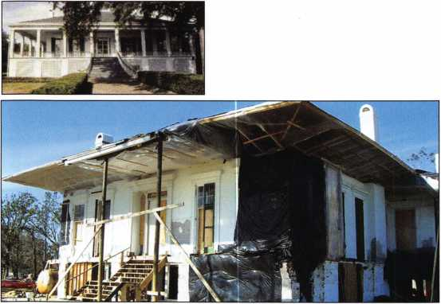

Beauvoir

One year. It has been twelve months since I made my trip to the Gulf Coast to survey the damage to my hometown, Gulfport Mississippi, and the surrounding areas in the wake of Hurricane Katrina. 365 days ago, my relatives living on the coast told me to stay in Texas, do not come home, its not the same. But I was determined to see for myself. After all, I had survived Hurricane Camille in 1969, at the time the worst storm to hit the United States on record. The storm that we all swore would never be repeated in our life­time. Once I arrived in Gulfport in the spring of 2006, I was devastated. The carnage left by the storm, the lives lost, the childhood locations damaged or destroyed was almost too much to bear. As I wrote that article one year ago, it was very therapeutic. And the more I wrote, the more I remembered the resilience of the people there and was sure that they would recover and things would be better than before. So it was with this thought in mind that I decided to return to Gulfport and check the progress, looking for a happy ending to a sad chapter.

As I drove through South Mississippi, the thing that struck me first was the lack of trees. Prior to Katrina, all along Interstate 10, trees were in abundance on both sides of the highway and so thick that you literally could not see day­light among them. A year ago, the trees still existed but a good majority were broken and twisted and leaning severely enough that the roots came through the top soil. Today, there are stretches of I-10 that have no trees beside the road and the foliage is so thinned that you can see through to secondary tree lines hundreds of yards from the roadway. The other thing that strikes me is the lack of green. Usually this time of year, the leaves on most of the trees are turning a vibrant green and the needles of the pine trees are almost always that same shade. Now, the coloration is sporadic.

The intensive concentration of salt water heaped upon these trees during the storm from blowing water and rain has everything a lovely shade of 70s earth tone brown.

But there are signs of recovery here. A year ago, all of the highrise billboards along this stretch of Interstate looked like a mangled, tangled mess of steel and paper, a tinker toy experiment gone horribly awry. Now those same billboards contain signs advertising the return of casino’s both old and new, restaurants and mercantile establishments. All with an uplifting message of rebuilding and recovering. Already this trip is yielding some positive feelings.

The first stop I make is at the corner of 25th Avenue and 19th Street at the location of Petes Electric, the company where my grandfather learned locksmithing. Back in 2006

Keynotes • May 2007

**mmrTi**

l l ABC J { PEP ,

MNO

7 8 9m

i // i l,wxv J

AMSEC has been a pioneer in the electronic lock market. The NEW ESLXL SERIES LOCKS offer unrivaled value in electronic safe access.

The ESLIOXL and ESL20XL series are better than ever offering proven protection with the best blend of features and functions. The ESLXL Series offers an attractive metal die-cast keypad housing with an alpha-numeric slanted keypad and an enhanced battery retention compartment. The ESL10XL is avail­able in polished brass, polished chrome or matte black finish. The ESL20XL comes standard with a matte black finish.

The ESLIOXL is a basic electronic lock for home and office applications. The ESL20XL offers advanced features necessary for commercial applications.

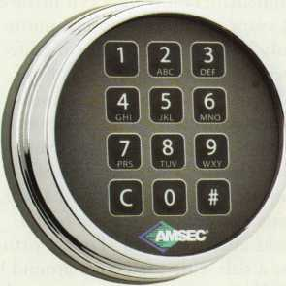

**ESLIOXL**

(shown in Chrome Finish)

TYPE I LISTED

**ESL20XL**

(shown in Matte Black Finish)

**ESLIOXL**

» Electronics are sealed to prevent possible moisture related failures.

» 15-minute Penalty Lockout after four incorrect entries.

» Patented dead-latched lock design with an internal relock device for maximum security.

» Lock "auto-locks" when boltwork is thrown » Slam Bolt version for locker applications.

» Factory Reset Combination for solving lost combinations. » Audible beep and flash from every key-stroke.

» Optional AC Power transformer.

ESL20XL/ Additional Features » Time Delay Mode: Delays can be set from 1 to 99 minutes. » Multiple User Mode: One Master Code and eight User Codes are available with full supervisory control and user management » Dual Control Mode: The lock can be programmed to require two combinations to open for added security.

»Armored Car Override: Allows an armored car service to bypass Time Delay.

» External A/C Power: Provides power for unlimited use with battery power as backup.

» Control Port: Turn the ESL20XL on/off with an Access Manager, Alarm System or other device.

**American Security Products Company T -800-421-6142 [www.amsecusa.com](http://www.amsecusa.com)**AMCFr r^c^rv/^c tho rinht tri unrlatt* nrnHnrt at nprpttarv AMSFC it not rocnonsiblo for **tvoooraDhical errors.**

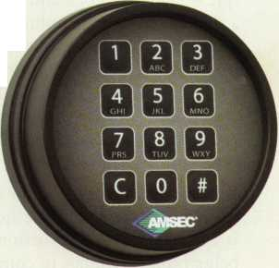

when I visited, all that remained of what must have been  
about a 7000 square foot building was a pile of wood and  
metal on a concrete slab. One end of the building was  
totally down while the other remained upright but unsta-  
ble. Today, there is nothing but a vacant lot. (pic - Pete’s  
Slab) Not even a small remnant of what once was.

However, across the street I notice a small block building.  
On the sign, “PETE’S ELECTRIC”, (pic - New Facility)  
The owners have taken the hand dealt them and moved  
on. They have moved their operation into a much smaller  
building but have remained close to the location they have  
occupied for so many decades, thus remaining easy for  
their customers to locate. Business, and life, goes on. Will  
they rebuild on the empty lot, probably. Will they let  
Katrina and its aftermath shut them down, absolutely not.  
Recovery continues.

Next stop, the location of Hancock Lock and Key, the last  
vestige of the family business started by my grandfather.  
Though no one in the immediate family has been involved  
in its operation in recent years, it still has a special mean-  
ing to us because obviously it was the beginning of a life-  
long career for almost everyone in my family. All of my  
uncles, some aunts, step brothers, half brothers, cousins,  
nieces, possibly even the family pets have been locksmiths  
at some point or another because of this little company.  
When last I visited, all that remained was a couple of  
columns from the roof support, a lot of debris and a slab. I  
am told keys and lock parts and even a safe were found  
scattered over several blocks after the storm. Today, virtu-  
ally nothing remains. Just a slab with a few trees around it,  
(pic - Hancock Lock and Key) and appropriately enough,  
a sign advertising demolition and debris removal. If you  
look at the tree just to the left of the slab, during the  
height of the storm, the surge from the gulf which is about  
? mile in the background and 10 feet below the slab level,  
was up near the top of the tree. That’s over 25 feet of  
water with waves crashing in another 10-12 feet above  
that. Just unbelievable.

But out of this rubble again rises hope. About 200 yards  
from where the shop once stood, amid all the barren land,  
is a house under construction.(pic - house on pilings) It is  
being built on pilings to comply with new ordinances  
required for building along the coast line, but the bottom  
line is that it is being built. Another resurrection.

I drove down Highway 90 along the beach looking at the  
places where the once majestic antebellum homes stood.  
The stately mansions that had endured so many storms  
and hurricanes over decades and even centuries were now  
gone. Some of the most historic homes in the country like  
Beauvoir, the last home of Jefferson Davis, the President of  
the Confederacy, (pic — beauvoir pre) A beautiful piece of  
history and architecture, open to the public for visits. Now  
(pic - beauvoir) just broken and twisted wood. Then there  
was Boggsdale. It had stood for over a hundred years and  
was the home of Robert Boggs, the writer and artist. Also

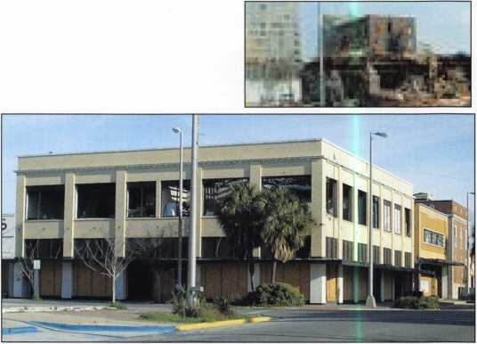

Downtown

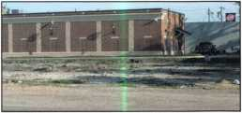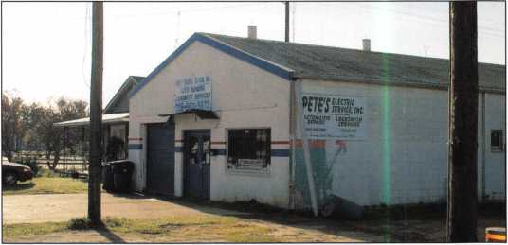

Pete’s Electric

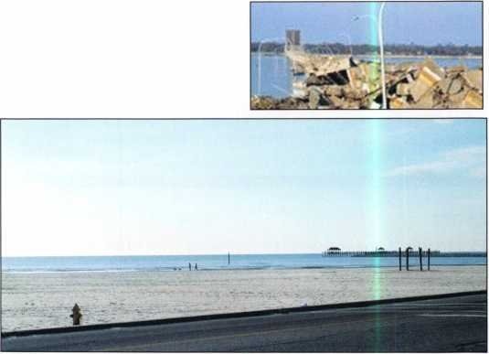

The Beach

**2**

Keynotes • May 2007

part of this historic family was Statesman Hale Boggs and National News Correspondent Cokie Roberts, (-pic - bog- gsdale)

Downtown Gulfport shows the contrast vividly of what things looked like immediately after the storm as well as how far they have progressed in a relatively short time. Downtown still shows the ravages of the high water and deadly winds, (pic - downtown 2). There are many office buildings like this old structure which housed law firms and realty agents, that are still boarded up and vacant, (pic - downtown) If you look closely at the brick you can still see the water line about three feet below the upper floor windows. Just two blocks away is where the First Baptist Church stood. Last year the sight of the church was some­thing to behold, (pic - First Baptist) Today all that remains is the steeple, awaiting a rebuild so it may be placed back atop, (pic - steeple) A little further up the beach from the old Church lot is an all too familiar sight, the FEMA trail­er, (pic - FEMA) The occupants of this trailer are strug­gling with the rebuilding process like many along the coast due to insurance delays and shortages of materials. The lot and slab that the trailer is sitting on is valued at $600 thousand dollars and is still mortgaged. You have to love red tape. The lot next door shows the contrast. This house was completed about 3 months ago. (pic - new house) Just a few blocks away is the new Island View Casino and Resort, (pic - new casino) Truly a testament to the resilience of the coastal residents. Not much more than a year ago the same area along Highway 90 looked like this, (pic - beach after)

And lastly, the thing you notice the most is the beach itself, (pic - beach) The calm smooth waters of the gulf, nice breeze, white sand. This is the way I remember Gulfport and the coastal areas the most as do most that have visited. This is also the most lasting image from my recent visit because all of the water born debris that lay on the sand beach and highway, all the debris floating in the water, the trees and limbs sticking up from the water, all gone. The beach looks exactly the way in did pre-Katrina. The way it has looked as long as I can remember. It is still hard to see the calm gulf waters and image it causing the damage that it caused.

The trip proved again to be therapy for me and my family.

I did not want the images left by the news coverage and by my last trip to be with me as the way I remembered “home”. Just as after Hurricane Camille in 1969, the Coastal residents have proven that though they may be knocked down by disasters, they will not allow them to keep them down. Like the Phoenix rising from the ashes, the coast is experiencing a rebirth.

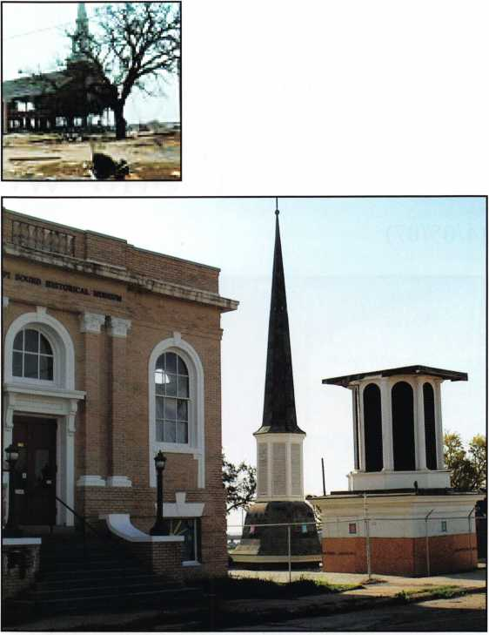

Steeple

After the damage of hurricane Katrina had been assessed, ALOA took action by constructing a website completed dedicated to helping those who lost their livelihood. Many of our members in the affected areas lost their shops and tools, and many of them lost their homes. This website offered a point of contact for members all over the country to offer assistance to those who needed it most. More than 30 companies and individuals logged on to offer employment. Others offered both employment and housing and some offered equipment and tools. Along with jobs and housing, many of our members took advantage of our online donation sys­tem to give monetarily.

In light of the response to this disaster, ALOA has decided to make this an ongoing effort to provide relief for those members who face unexpected hardships. The ALOA Disaster Relief Fund will serve to offer financial assistance to those who face disasters of any kind, whether it is a natural disaster such as Katrina or another loss such as fire - or even extraordinary circumstances such as terrorist attacks. Already some of the money we have received has been used for those who have endured hardship from Katrina. This assis­tance has been greatly appreciated.

Getting involved is simple. If you have access to the internet, sim­ply log on to the ALOA store at <http://www.aloa.org/store> and click the icon for the Disaster Relief Fund. You can choose the amount you would like to donate by adding the proper amount to your online basket. If you do not have access to the internet or would simply like more information about this ongoing effort, please call the ALOA headquarters at 214-819-9733 or toll free at 800-532-2562.

Keynotes • May 2007

News Release :

Three Weeks Under Water after Katrina, and Still Working!

(4/05/07)

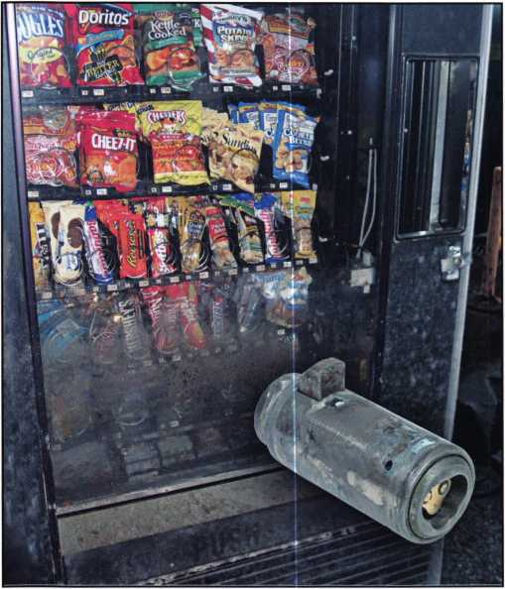

CORVALLIS, OREGON, — CyberLock® electronic lock cylinders were put to an extreme test during Hurricane Katrina. Many vending machines belonging to Whitener Snacks in New Orleans were under water for three weeks. During clean-up after the storm, they were amazed to find the CyberLocks on machines that had been submerged in mud and water were still working. Andy Hilverda, Vice President of Videx, says, “CyberLocks are designed to withstand the harshest con­ditions, and although surviving a hurricane goes beyond what we envisioned, CyberLock certainly proved to be more than up to the task.”

Henry Guste, Chief Operating Officer of Whitener Snacks dba Refreshment Solutions, says, “We researched all the options out there and decided to go with CyberLock because we needed the flexibility it offers.

We were experiencing serious shortages of products from our machines. The audit trail is very important to us. With CyberLock we are able to monitor who is getting into our machines, and when. The system allows us to limit our drivers’ access to the machines to given times. For added security we have a CyberLock cylinder in the deadbolt on the door to our Money Room and have sev­eral CyberLock padlocks on our warehouse. We are pleased with the system, and recommend CyberLock for companies that are experiencing the problems we were having.”

With CyberLock, mechanical lock hardware can be quickly converted to a high-security electronic lock sim­ply by replacing the existing lock cylinder with the CyberLock electronic cylinder. CyberLocks cannot be picked and the keys cannot be duplicated. Each key con­tains permissions on what locks the key can open, with a schedule of days and times it will open those locks.

Each time the key opens a lock, a record is stored in both the key and the lock, creating an audit report of events.

Keynotes • May 2007

Dale/Time

**jEast Entrance West Enhance** Records Room Computer Room West Entrance **Computer Room Computer Room**

03/20/2007 08:14:22 AM Denied

**03/20/2007 07:28:03AM** KeyAut **03/20/2007 07:59:15AM** Out of $

03/20/2007 08:00:03 AM Ke * '

**Abby Chaney Pete**S**ussman John Michaels Svefrn Lefler** Juanita Banks **Anrfr Dunsmore**

03/^0/200708:12:16 AM

r ^**0/200708:18:52AM**

*^30708:27:14

0°u' Replace standard door lock cylinders with CyberLock cylinders in minutes.

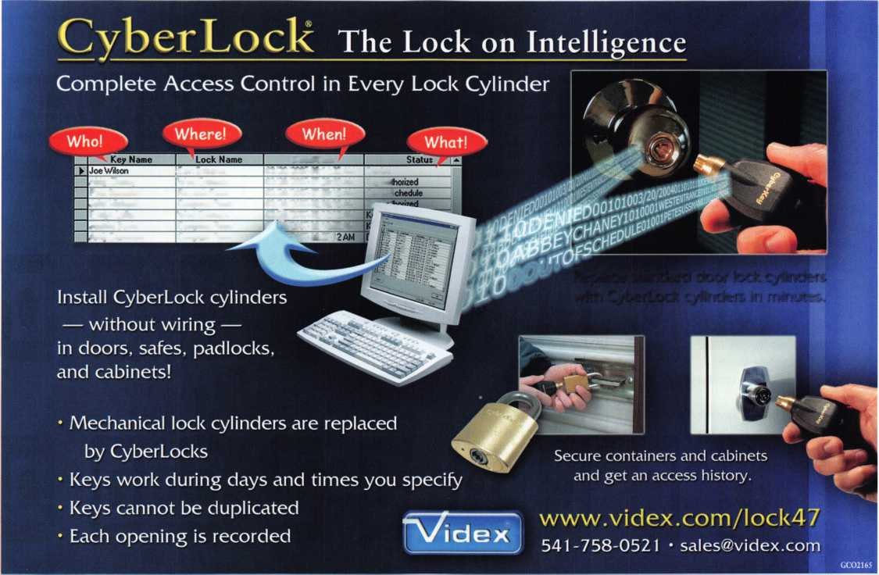

*You could* win a$l 00 American Express *gift card*

by participating in this 2007 ALOA Member Survey!

Your feedback is essential in assisting ALOA in preparing to meet the changing needs of those it serves - you, our members. The purpose of this survey is to learn about your experi­ences and perceptions of the association. The results will allow us to shape the future of ALOA and to meet the needs of the Locksmith/access control industry.

All responses ore confidential and anonymous. Please do not write your name anywhere on the questionnaire. Your answers will be combined with those of other members for statistical analysis by Mitchell & McCue Marketing Services. Only coupons will be forwarded to ALOA.

Please complete the survey and the enclosed coupon and return both by May 28th. Your cooperation and prompt response is important in helping us shape the future of the association.

A summary of results will appear in a future issue of Keynotes. Thank you and good luck in the drawing I. If you have any questions please call Ellen McEwen, Membership Development Manager at 800-532-2562 ext 203.

PART 1

1. Please use the scale to indicate  
   how important each of the follow-  
   ing is to you personally in your job.

Very unimportant 1

Somewhat unimportant 2

Neither important nor unimportant 3

Somewhat important 4

Very important 5

Advocacy/legislative actions

Educational programs for certification

Ability to take educational courses on

the Internet

ALOA Convention and Security Expo

ALOA website

Keynotes mqaim

Affiliation with ALOA (for example,

access to manufacturers' codes)

Clear Star website discount

Involvement in local chapters or affili-  
ates

Becoming a better business owner

"Find a Locksmith" link for con-  
sumers on the ALOA website

Enhancing the image of locksmiths

among the general public  
 Value of my membership versus cost

PART 2

1. Please use the scale to indicate  
   how satisfied you are in the  
   ALOA's ability to provide each of

the following:

Very unimportant 1

Somewhat unimportant 2

Neither important nor unimportant 3

Somewhat important 4

Very important 5

Advocacy/legislative actions

Educational programs for certification

Ability to take educational courses on

the Internet

ALOA Convention and Security Expo

ALOA website

**Keynotes** magazine

Affiliation with ALOA (for example,

access to manufacturers' codes)

Clear Star website discount

Involvement in local chapters or affili­ates

Becoming a better business owner

"Find a Locksmith" link for con­sumers on the ALOA website

Enhancing the image of locksmiths

among the general public Value of my membership versus cost

1. Please use the scale to indicate  
   how important each of the follow-  
   ing ALOA legislative initiatives is  
   to you personally in your job.

Very unimportant 1

Somewhat unimportant 2

Neither important nor unimportant 3

Somewhat important 4

Very important 5

Working with individual state legisla-  
tors to implement licensing laws  
 Assuring members access to automo-  
tive key codes

1. Please use the scale to indicate how satisfied you are in ALOA's efforts on those legislative issues.

Very unsatisfied 1

Somewhat unsatisfied 2

Neither satisfied nor unsatisfied 3

Somewhat satisfied 4

Very satisfied 5

Don't know/not applicable to me personally 6

Working with individual state legisla-  
tors to implement licensing laws  
Assuring members access to automo-  
tive key codes

1. Now, please think about how valu­able ALOA is to you in your job. Would you say it is more or less valuable to you today than it was two years ago?

* More valuable
* The same
* Less valuable
* Not sure

1. And again, compared to today, do you think ALOA will be more or less valuable to you in the next two years?

* More valuable n The same
* Less valuable
* Not sure

1. Why do you feel that way about ALOA in the future?

8. How valuable are the following ALOA educational tracks to you in your job?

Automotive

Not at all valuable 1

Somewhat invaluable 2

Neither invaluable nor valuable 3

Somewhat valuable 4

Very valuable 5

Am not familiar 6

General Security

Not at all valuable 1

Somewhat invaluable 2

Neither invaluable nor valuable 3

Somewhat valuable 4

Very valuable 5

Am not familiar 6

Safe and Vault 1 2

3

4

5

6

Business Management 1 2

3

4

5

6

General Locksmithing 1 2

3

4

5

6

Specialty (Access Control) 1 2

3

4

5

6



9. How valuable is the information provided to you in various publications, such as **Keynotes, National Locksmith** and **Locksmith Ledger?**

Keynotes

Not at all valuable 1

Somewhat invaluable 2

Neither invaluable nor valuable 3

Somewhat valuable 4

Very valuable 5

Am not familiar/do not read the pub. 6

National Locksmith 1 2

3

4

5

6

Locksmith Ledger 1 2

3

4

5

6

**Please send by May 28, 2007 to:  
Mitchell & McCue • Marlou Huibonhoa  
1853 Silva Place • Santa Clara, Ca 95054  
Fax: 214-324-4111**

Keynotes • May 2007

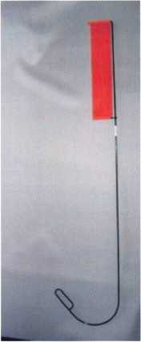

Patent

Emergency Door Opening Tods

AS SEEN AT THE 2006 A.L.O.A CONVENTION

All commercial buildings have two things in common:

* Fire code requires that all commercial locks open by a single action.
* The American Disability Act requires free access through doorways, which leaves a gap between the door and the floor.

w

Knoblock Tool

Leverlock Tool

WITH THIS IN MIND WE HAVE DEVELOPED THE TOOLS REQUIRED TO EFFECTIVELY  
OPEN DOORS QUICKLY AND WITHOUT DAMAGE

Designed for interior commercial doors

For knoblocks, the tool is slid under the door with no cords to pull or get tangled.

For leverlocks, a similar tool is used by applying the same method of sliding the tool under the door and pull until the lever retracts.

Both tools are designed to work with very little effort, excessive force is not needed.

Visit our web site at [WWW.THEBEN-JIM.COM](http://WWW.THEBEN-JIM.COM) for more details.

THE BEN-JIM KNOBLOCK TOOL $ 99.00

THE BEN-JIM LEVERLOCK TOOL $ 79.00

SET (one each) $ 169.00

PLUS SHIPPING & HANDLING

**TO PLACE AN ORDER CALL 1-586-778-1911 OR VISIT US AT [WWW.THEBEN-JIM.COM](http://WWW.THEBEN-JIM.COM)**

MADE IN THE U.S.A BY THE BEN-JIM CORPORATION.

24711 Harper Ave. * St. Clair Shores * MI * 48080 * (Fax) 586-778-0530

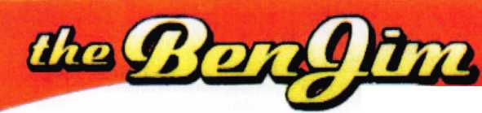

**Please send by May 28, 2007 to: Mitchell & McCue • Marlou Huibonhoa  
1853 Silva Place • Santa Clara, Ca 95054 • Fax: 214-324-4111**

PART 3

10. Thinking about various publications such as Keynotes, National Locksmith 11. Please use the scale to indicate how satisfied you are in various publico-

and Locksmith Ledger use the scale to indicate how important each of the tions, such as the Keynotes, National Locksmith, and Locksmith Ledger

|  |  |  |  |  |  |  |  |
| --- | --- | --- | --- | --- | --- | --- | --- |
| following are to you: | |  |  | ability to provide each of the following: | | |  |
| Feature Articles | Keynotes | National Locksmith | Locksmith Ledger | Feature Articles | Keynotes | National Locksmith | Locksmith Ledger |
| Not at all valuable | 1 | 1 | 1 | Not at all valuable | 1 | 1 | 1 |
| Somewhat invaluable | 2 | 2 | 2 | Somewhat invaluable | 2 | 2 | 2 |
| Neither invaluable nor valuable 3 | | 3 | 3 | Neither invaluable nor valuable 3 | | 3 | 3 |
| Somewhat valuable | 4 | 4 | 4 | Somewhat valuable | 4 | 4 | 4 |
| Very valuable | 5 | 5 | 5 | Very valuable | 5 | 5 | 5 |
| Am not familiar | 6 | 6 | 6 | Am not familiar | 6 | 6 | 6 |
| Advertising | Keynotes | National Locksmith | Locksmith Ledger | Advertising | Keynotes | National Locksmith | Locksmith Ledger |
| Not at all valuable | 1 | 1 | 1 | Not at all valuable | 1 | 1 | 1 |
| Somewhat invaluable | 2 | 2 | 2 | Somewhat invaluable | 2 | 2 | 2 |
| Neither invaluable nor valuable 3 | | 3 | 3 | Neither invaluable nor valuable 3 | | 3 | 3 |
| Somewhat valuable | 4 | 4 | 4 | Somewhat valuable | 4 | 4 | 4 |
| Very valuable | 5 | 5 | 5 | Very valuable | 5 | 5 | 5 |
| Am not familiar | 6 | 6 | 6 | Am not familiar | 6 | 6 | 6 |
| Classifieds | Keynotes | National Locksmith | Locksmith Ledger | Classifieds | Keynotes | National Locksmith | Locksmith Ledger |
| Not at all valuable | 1 | 1 | 1 | Not at all valuable | 1 | 1 | 1 |
| Somewhat invaluable | 2 | 2 | 2 | Somewhat invaluable | 2 | 2 | 2 |
| Neither invaluable nor valuable 3 | | 3 | 3 | Neither invaluable nor valuable 3 | | 3 | 3 |
| Somewhat valuable | 4 | 4 | 4 | Somewhat valuable | 4 | 4 | 4 |
| Very valuable | 5 | 5 | 5 | Very valuable | 5 | 5 | 5 |
| Am not familiar | 6 | 6 | 6 | Am not familiar | 6 | 6 | 6 |
| News | Keynotes | National Locksmith | Locksmith Ledger | News | Keynotes | National Locksmith | Locksmith Ledger |
| Not at oil valuable | 1 | 1 | 1 | Not ot all valuable | 1 | 1 | 1 |
| Somewhat invaluable | 2 | 2 | 2 | Somewhat invaluable | 2 | 2 | 2 |
| Neither invaluable nor valuable 3 | | 3 | 3 | Neither invaluable nor valuable 3 | | 3 | 3 |
| Somewhat valuable | 4 | 4 | 4 | Somewhat valuable | 4 | 4 | 4 |
| Very valuable | 5 | 5 | 5 | Very valuable | 5 | 5 | 5 |
| Am not familiar | 6 | 6 | 6 | Am not familiar | 6 | 6 | 6 |
| Technical Information | Keynotes | National Locksmith | Locksmith Ledger | Technical Information | Keynotes | National Locksmith | Locksmith Ledger |
| Not at all valuable | 1 | 1 | 1 | Not at all valuable | ] | 1 | 1 |
| Somewhat invaluable | 2 | 2 | 2 | Somewhat invaluable | 2 | 2 | 2 |
| Neither invaluable nor valuable 3 | | 3 | 3 | Neither invaluable nor valuable 3 | | 3 | 3 |
| Somewhat valuable | 4 | 4 | 4 | Somewhat valuable | 4 | 4 | 4 |
| Very valuable | 5 | 5 | 5 | Very valuable | 5 | 5 | 5 |
| Am not familiar | 6 | 6 | 6 | Am not familiar | 6 | 6 | 6 |
| Crime Prevention | Keynotes | National Locksmith | Locksmith Ledger | Crime Prevention | Keynotes | National Locksmith | Locksmith Ledger |
| Not at all valuable | 1 | 1 | 1 | Not at all valuable | 1 | 1 | 1 |
| Somewhat invaluable | 2 | 2 | 2 | Somewhat invaluable | 2 | 2 | 2 |
| Neither invaluable nor valuable 3 | | 3 | 3 | Neither invaluable nor valuable 3 | | 3 | 3 |
| Somewhat valuable | 4 | 4 | 4 | Somewhat valuable | 4 | 4 | 4 |
| Very valuable | 5 | 5 | 5 | Very valuable | 5 | 5 | 5 |
| Am not familiar | 6 | 6 | 6 | Am not familiar | 6 | 6 | 6 |
| Calendar of Upcoming Locksmith Activities and Events | | |  | Calendar of Upcoming Locksmith Activities and Events | | |  |
|  | Keynotes | National Locksmith | Locksmith Ledger |  | Keynotes | National Locksmith | Locksmith Ledger |
| Not at all valuable | 1 | 1 | 1 | Not at all valuable | 1 | 1 | 1 |
| Somewhat invaluable | 2 | 2 | 2 | Somewhat invaluable | 2 | 2 | 2 |
| Neither invaluable nor valuable 3 | | 3 | 3 | Neither invaluable nor valuable 3 | | 3 | 3 |
| Somewhat valuable | 4 | 4 | 4 | Somewhat valuable | 4 | 4 | 4 |
| Very valuable | 5 | 5 | 5 | Very valuable | 5 | 5 | 5 |
| Am not familiar | 6 | 6 | 6 | Am not familiar | 6 | 6 | 6 |
| Legislative Update Articles | |  |  | Legislative Update Articles | |  |  |
|  | Keynotes | National Locksmith | Locksmith Ledger |  | Keynotes | National Locksmith | Locksmith Ledger |
| Not at all valuable | 1 | 1 | 1 | Not at all valuable | 1 | 1 | 1 |
| Somewhat invaluable | 2 | 2 | 2 | Somewhat invaluable | 2 | 2 | 2 |
| Neither invaluable nor valuable 3 | | 3 | 3 | Neither invaluable nor valuable 3 | | 3 | 3 |
| Somewhat valuable | 4 | 4 | 4 | Somewhat valuable | 4 | 4 | 4 |
| Very valuable | 5 | 5 | 5 | Very valuable | 5 | 5 | 5 |
| Am not familiar | 6 | 6 | 6 | Am not familiar | 6 | 6 | 6 |

**18**

Keynotes • May 2007

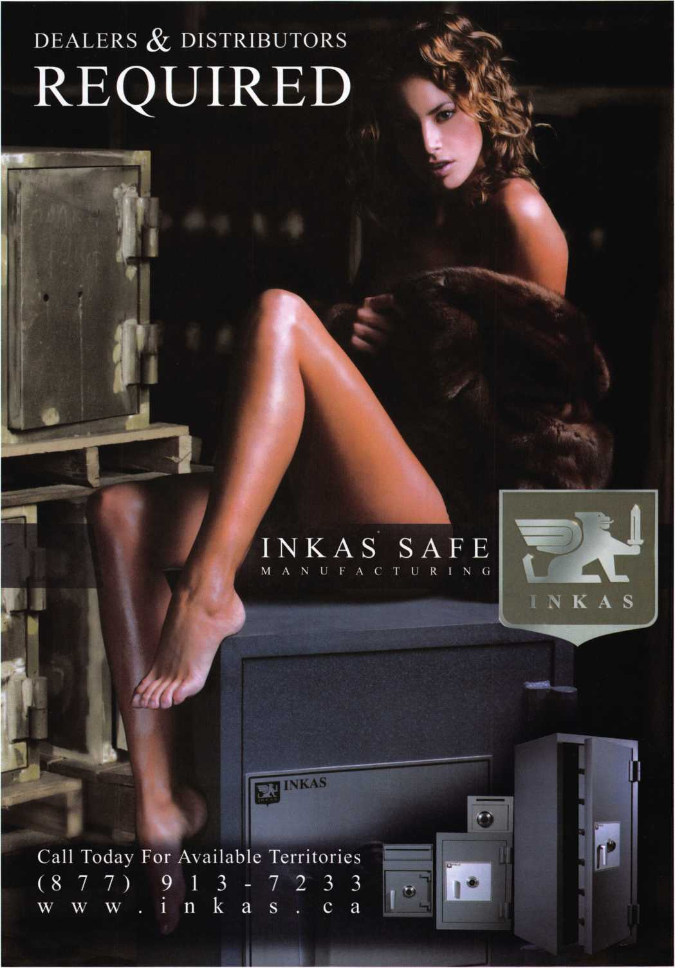

PART 4

**Please send by May 28, 2007 to: Mitchell & McCue • Marlou Huibonhoa  
1853 Silva Place • Santa Clara, Ca 95054 • Fax: 214-324-4111**

12. How likely would you be to recommend an ALOA membership

to a colleague?

Very unlikely 1

Somewhat unlikely 2

Neither likely nor unlikely 3

Somewhat likely 4

Very likely 5

**13. Why** would you recommend, or not recommend, membership to a colleague?

14. In your job, how valuable is it to you to be a Certified ALOA Locksmith?

Not at all valuable 1

Somewhat invaluable 2

Neither invaluable nor valuable 3 Somewhat valuable 4

Very valuable 5

15. Please use the scale to indicate how important ALOA Certification is when you consider the following.

Generates More Business

Very unimportant 1

Somewhat unimportant 2

Neither important nor unimportant 3 Somewhat important 4

Very important 5

Time it Takes to Become Certified

Very unimportant 1

Somewhat unimportant 2

Neither important nor unimportant 3 Somewhat important 4

Very important 5

Keeps Me Current with Technology

Very unimportant 1

Somewhat unimportant 2

Neither important nor unimportant 3

Somewhat important 4

Very important 5

Gives Me Valuable Training

Very unimportant 1

Somewhat unimportant 2

Neither important nor unimportant 3

Somewhat important 4

Very important 5

Ensures Customers of My Background Check

Very unimportant 1

Somewhat unimportant 2

Neither important nor unimportant 3

Somewhat important 4

Very important 5

Makes Me Different than Other Locksmiths

The Cost to Complete the Certification

Very unimportant 1

Somewhat unimportant 2

Neither important nor unimportant 3

Somewhat important 4

Very important 5

Making the Course More Available to me via the Internet

Very unimportant 1

Somewhat unimportant 2

Neither important nor unimportant 3

Somewhat important 4

Very important 5

Fulfills My State Licensing Requirement

Very unimportant 1

Somewhat unimportant 2

Neither important nor unimportant 3

Somewhat important 4

Very important 5

Very unimportant 1

Somewhat unimportant 2

Neither important nor unimportant 3 Somewhat important 4

Very important 5

16. What could ALOA do that would make your membership more valuable to you?

17. What other education topics would be valuable to you?



Keynotes • May 2007

1. What is your primary job focus? (Choose only one).

* Institutional
* Commercial
* Schools
* Government
* Automotive
* Residential
* Commercial
* Safe & Vault
* Electronic security (Access Control)

1. Which other areas have you engaged in over the last 30 days? Choose all that apply.

* Institutional
* Commercial
* Schools
* Government
* Automotive
* Residential
* Commercial
* Safe & Vault
* Electronic security (Access Control)
* Other

1. Please indicate which below best describes your job function:
2. Owner
3. Partner/Decision-maker
4. Technician
5. Apprentice/trainee
6. Other
7. Which best describes your work environment. Please choose one.

* Storefront and mobile
* Mobile only
* Institutional
* Government

1. Please indicate the annual gross sales of your organization.
2. $0-$60,000
3. $60,001 -$120,000
4. $120,001 -$250,000
5. $250,001-$500,000
6. $500,001 +
7. What are your company's annual resale hardware sales?

* $0-$30,00
* $30,0001-$60,000
* $60,0001 -$125,000
* $125,001 -$250,000
* $250,001 +

1. How long have you been a security professional?
2. Less than 10 years
3. 10 years but less than 25 years
4. 25 years or more
5. Please indicate your age.
6. Less than 30 years old
7. 30 years but less than 45 years old
8. 46 years but less than 60 years old
9. Over 60 years of age
10. Please indicate how often you use

the following:

|  |  |  |  |  |
| --- | --- | --- | --- | --- |
|  | Daily | Weekly | Monthly | Never |
| Email | □ | □ | □ | □ |
| Internet | □ | □ | □ | □ |
| PDA | □ | □ | □ | □ |
| ALOA Website | □ | □ | □ | □ |

I Fill in the coupon below to be entered in the drawing. I

I Please send your survey and coupon by no later than May 28th, 2007. |

**•** Please enter me in the drawing for one of ten American Express gift card. (To **J J** be eligible, you MUST complete the survey and fill in your name and member **J** | number below. Your responses will be kept confidential. Only coupons will be [ **J** forwarded to ALOA for the drawing. **J**

Name:

Member Number:

Please take a few minutes to update your contact information if you have any changes:

Mailing Address:

I City State Zip: I

I Phone: Fax: I

**J** Email: **J**

k———————J

S*

*

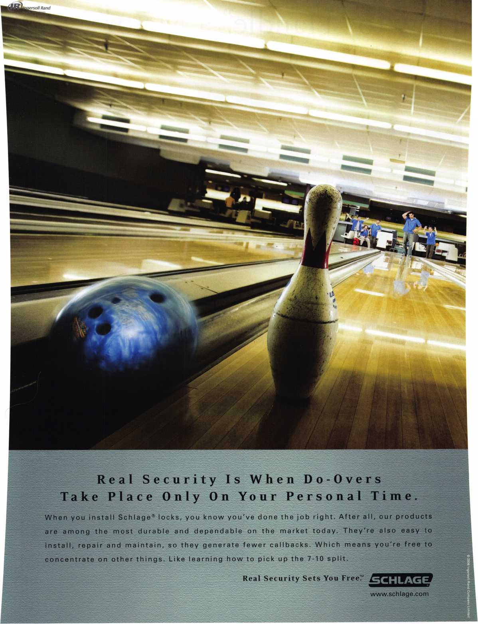

How to “Handle” a Major

By Greg Perry, CML, CPS

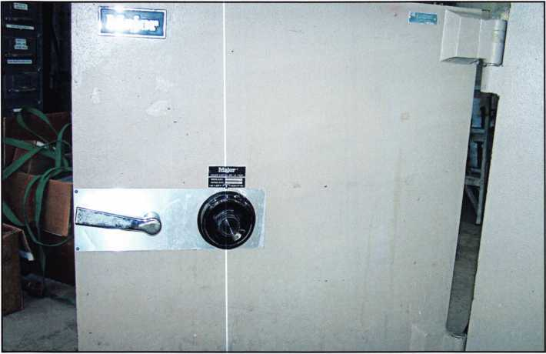

Photo 1

Major Safe  
has always  
been known  
for creating  
quality safes.

Major Safe has always been known for creating quality safes. They produced round doors, fire safes, square doors, and even lug doors. Their TL design commands respect among safecrackers. The TL rated safes pictured in this article were made around 1992 shortly before American Security Products or AMSEC purchased Major Safe. The two safes pictured in this article were produced prior to this merger. Parts for these safes are still available from AMSEC. These safes did not need to be opened, instead they needed a little work after being neglected for several years; the customer also wanted them stacked.

We found a bent handle on one and the detent pivot on the other was broken. Disassembling these safes is not difficult; it’s the reassembling that can be a little chal­lenging. The bolt extension spring is heavy and if you use your fingers to move it into place it can leave them a little bruised, better to use pliers to assemble this door.

Disassembling starts with removing the sheet metal door cover, then lock back cover, this will fire the relock, or does it? The relock seen up close in photos 2 and 3 on this design is designed to fire not only if the lock back cover is punched but also if the handle cam is punched.

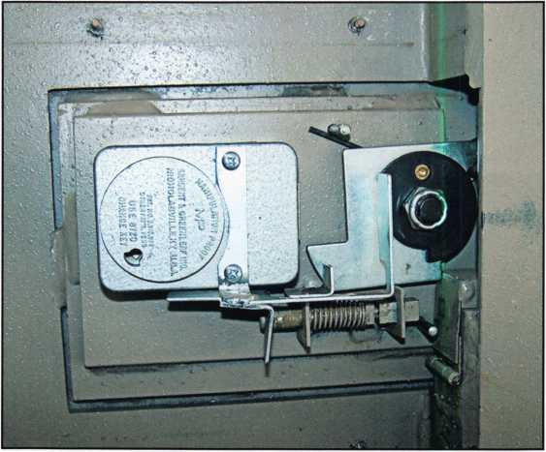

Photo 2

Keynotes • May 2007

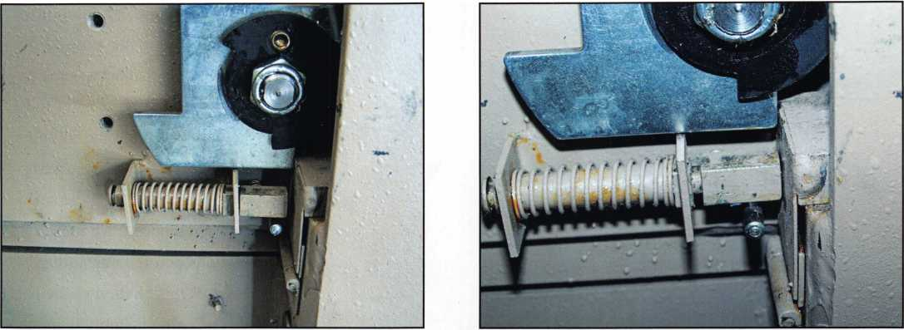

Photo 3 Photo 4

The relock plunger is designed to push or fire against the  
hinged flapper. There is a cutout in the bolt seen in  
photo 4 that effectively keeps the plunger from being  
pushed back. When the plunger is against the flapper it  
keeps it from moving. The gap between the end

of the relock plunger and flapper is too great on  
both these safes. On both doors the handle still  
turns with the back cover removed. The relock  
mounting bracket on both safes were mounted a  
little too far away from the hinged flapper to pre-  
vent the flapper from moving out of the way.

Bending the bracket towards the flapper solved  
this problem. Keep this in mind if you ever run  
into one of these safes after a burglary attempt,  
the handle might just turn or turn with a little  
persuasion from a deadblow hammer on the  
door. If not probably the best option is to drill  
and punch the bracket of the door.

The lock is removed in a very standard way by  
removing the spline key and because this is an  
S&G 8400 series lock, then the inner spindle.

Next unscrew the dial from the drive cam,  
remove it and unscrew the lock mounting screws  
to remove it. Getting back to the replacement of  
the handle and the detent trigger, lets look at the

handle system. Since the lock is now removed the next step is to remove the nut seen in photo 5 on the back of the handle. Photo 6 shows what happens as the cam plate is removed, the spring and the three-piece arbor

IN-STOCK...MORE SAFES

***FREE Freight Program***

*(30 States)*

FireKing

Bardall **hayman**

MEILINK **y/CTOR.**

TURD lO

**WHOLESALE SERVICE**

800**-**848-9790



Keynotes • May 2007

photo 7 can move a little further  
down allowing the removal of  
the roll pins that act as the con-  
nection between the bolts and  
the bolt bar. After the roll pins  
are both removed all the parts  
can be removed from the safe  
door. In this case we lubricated  
the bolts before reinstalling  
them. Reinstallation of the han-  
dle and cam assembly is in the  
reverse order of disassembly;  
the difficult part is keeping the  
spring in position as the cam is

installed on the shaft. The best method I have found is  
to use a pair of pliers to hold the spring as the cam is  
installed. It might not be perfect but it saves the fingers.

Photo 5 Photo 6

assembly fall apart. In the picture you can see one half of two-piece arbor still on the shaft and the second lying below the shaft on top of the relock plunger. Normally at this point the handle cam assembly can be reassem­bled with a new spring or in this case a new handle. Before reassembling this safe we’ll take a look at the boltwork normally covered by a welded in channel.

f^

You need it When?

**How about now!? :-)**

**ClearStar**

Se«orkV

Another Special  
Value-added Benefit to your

ALOA Membership! Click here...__

|  |  |  |
| --- | --- | --- |
|  | r \  [www.clearstar.com](http://www.clearstar.com) / ALOA  s. ) |  |
| V |  | ) |

The two bolts can only be removed after the cam is removed. Looking back at photo 5 you can see a chrome cap covering a hole in the welded channel for the bottom bolt and the exposed hole over the top bolt. Once the cam is removed the bolt bar seen in

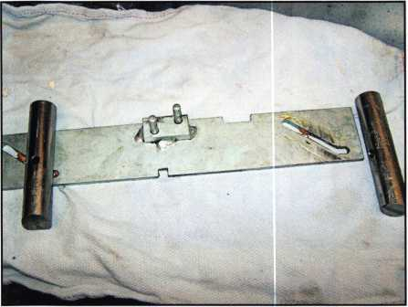

Photo 7



Keynotes • May 2007

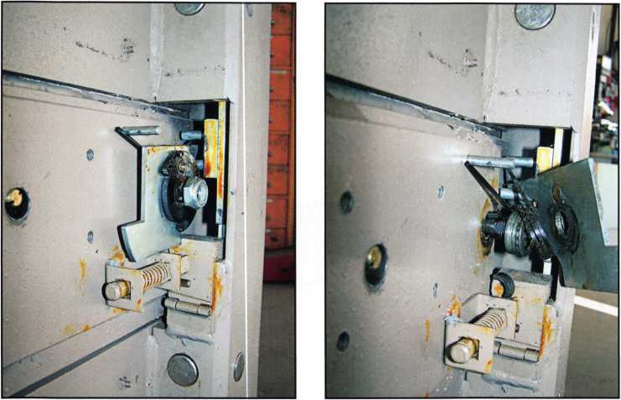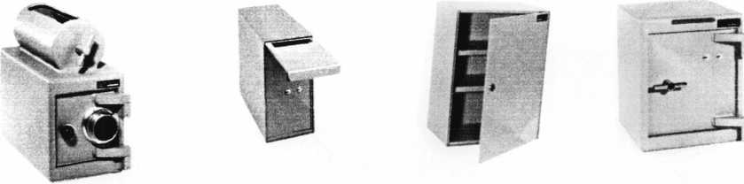

A & B Safe Corporation

Manufacturers of Quality Depository Safes & Chests



114 South Delsea Dr. Suite 3  
Glassboro, NJ 08028

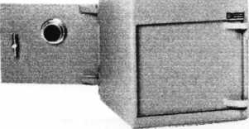

800-253-1267 Fax 856-863-1208

[info@a-bsafecorp.eom](mailto:info@a-bsafecorp.eom)

[www.a-bsafecorp.com](http://www.a-bsafecorp.com)

m

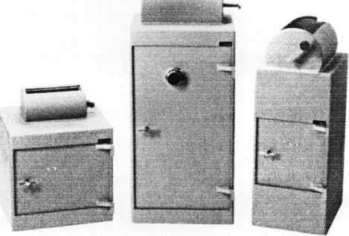

Over Seventy-Five Models In Stock

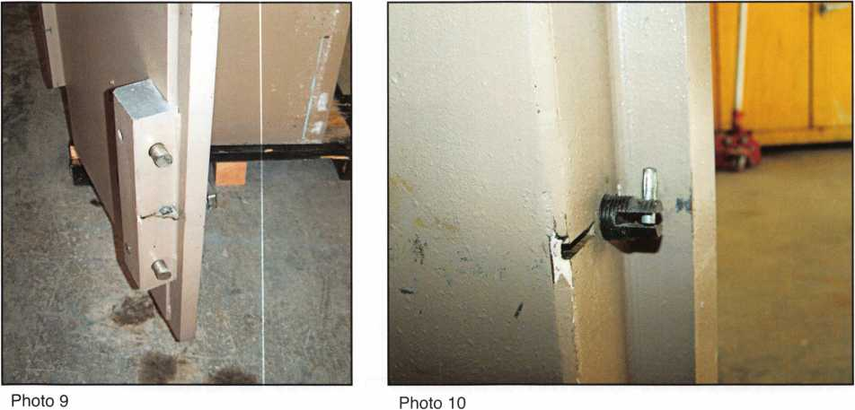

The other safe door seen in photo 9 and 10 needed the bolt detent replaced. This is easily accomplished by tap­ping out the solid pin or axle seen in photo 10 and replacing the detent plate. Next the two safes were care­fully stacked one on top of the other and holes drilled between the two units to bolt them together at the front of the safes. A strap was applied across the back to

secure the two units together. This will allow them to be easily separated in the future if the customer’s needs change.

Major Safe Company safes will be around for a good long time, even though they are no longer produced. Understanding how they operate and how to service them will earn you lots of money into the future.

**FOR THE OFFICE OF ALOA PRESIDENT  
Ken Kupferman, CML, CPS**

Your Participation Is Needed For The Future of OUR Industry. If you want to help  
make a difference in our industry, exercise one of your most important rights as a  
member of this association and participate in this year’s election. Were you aware  
that less than 10% of our membership has voted in past elections? That’s only 600  
-800 members. This year every position has several nominees so your vote can and  
will make a difference in the direction the association takes to lead our industry. For  
the last four years I have had the privilege to serve as your Southeast Director. I  
believe our association has grown greatly during this period. In these last four years  
we have accomplished many things, here are just a few:

* Instituted background checks for all new members.
* Created the Business Owners’ Group to help those who are operating both large and small companies.
* Introduced a company membership to help those with more than 3 employees,
* Relocated our headquarters to allow better educational opportunities for all members.
* Currently creating online educational opportunities for those members unable to travel.

First and foremost exercise your right to VOTE!! And when you do, please consider my qualifications to serve as  
your next President, leading this great organization through the next 2 years. Please visit

**[www.votealoapres2007.com](http://www.votealoapres2007.com)** for more information.

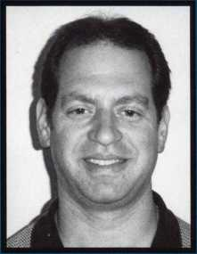

Keynotes • May 2007

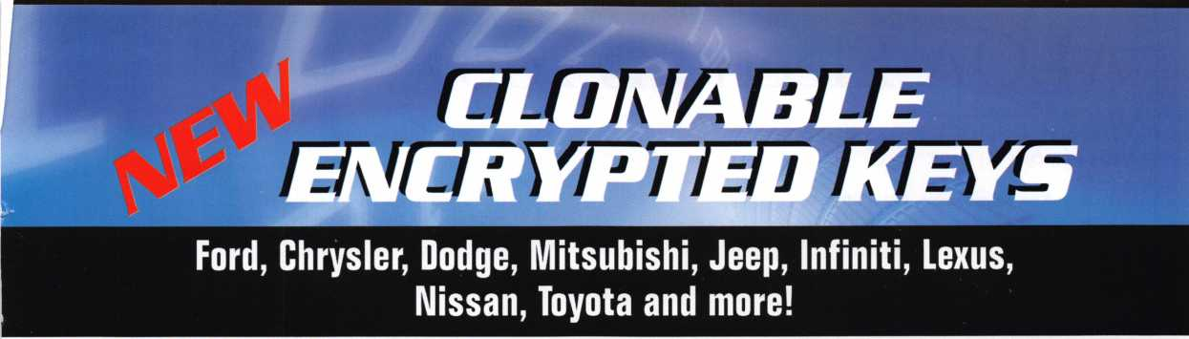

REPLI-CODE 7 TX

Includes updated software  
to clone encrypted keys

**♦ Small Head Shape ♦ 13 Blades Available ♦ Innovative Technology ♦Convenient Interchangeable Design Fobs Available for Fixed and Encrypted**

a BIANCHI1770GROUR Company

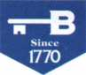

**BIANCHI**

USA, Inc.

**800.891.2118**

**[www.bianchil770usa.com](http://www.bianchil770usa.com)**

**Leaders in Automotive Key Cutting Technology**

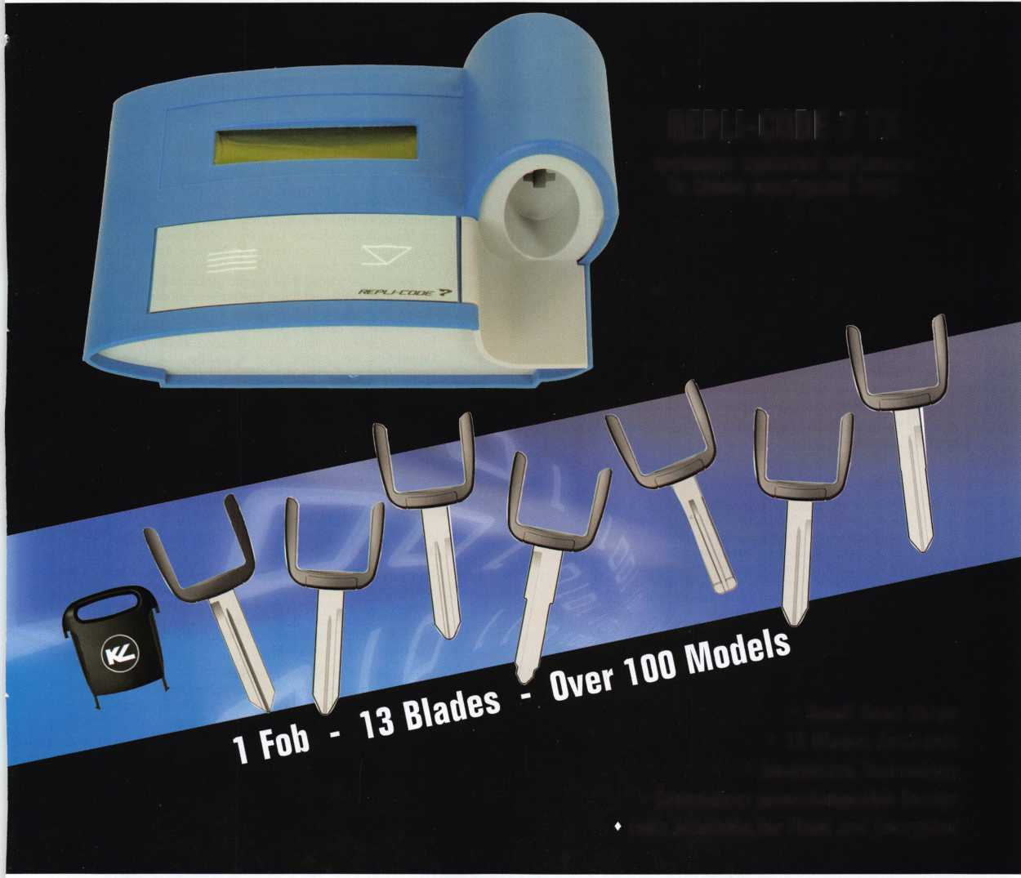

ALOA Elections 2007

**FOR THE OFFICE OF PRESIDENT**

VOTE FOR ONE (1) ONLY

Ken Kupferman, CML, CPS

Your Participation Is Needed For The Future of OUR  
Industry

If you want to help make a difference in our industry,  
exercise one of your most important rights as a member  
of this association and participate in this year's elec-  
tion. Were you aware that less than 10% of our mem-  
bership has voted in past elections? That's only 600 -  
800 members.

This year every position has several nominees so your  
vote can and will make a difference in the direction the  
association takes to lead our industry.

For the last four years I have had the privilege to serve  
as your Southeast Director. I believe our association has  
grown greatly during this period. In these last four  
years we have accomplished many things, here are just

a few:

* Instituted background checks for all new members.
* Created the Business Owners' Group to help those  
  who are operating both large and small companies.
* Introduced a company membership to help those  
  with more than 3 employees,
* Relocated our headquarters to allow better educa-  
  tional opportunities for all members.
* Currently creating online educational opportunities  
  for those members unable to travel.

First and foremost exercise your right to VOTE!! And  
when you do, please consider my qualifications to  
serve as your next President, leading this great organi-  
zation through the next 2 years.

Please visit [www.votealoapres2007.com](http://www.votealoapres2007.com) for more  
information.

James Jeffries, CPL, CPS

Many of you know me from the many classes I have  
taught for ALOA, SAVTA, and many local associations.  
As a past N.W. Director and active member of the  
ALOA Executive Board, I have helped bring about many  
positive changes and advancements in the last few  
years. It is now time for us to move forward and make  
other beneficial changes for the benefit of all ALOA  
members and the industry in general. Education is the  
key to dealing with the issues we all face today and in  
the future. As your President, I will guide this wonderful  
organization to achieve these changes. I am a propo-  
nent of the right kind of industry licensing. We must all  
get involved in making sure that any enacted licensing  
benefits all trades concerned. This includes the lock-  
smith, the automotive technician, the safe technician,  
the access-control technician and the alarm technician.  
By working with both government and the manufacturing  
sector, we can insure that whatever changes are made  
benefit all involved, not just a select few. Lapses in the  
past have resulted in members being locked out of their  
chosen field. By concentrating our efforts, we can try to  
prevent that from ever happening again. I would like to  
see a federal standard set for locksmiths that is fair to  
all. This has only been done in the transportation indus-  
try with the advent of the CDL license for truckers. It is  
time to consider something similar for the physical secu-  
rity industry. Now is the time to set the direction that our  
industry will take. Positive changes take time to do and  
one must start somewhere. Proper leadership is critical  
for our future and I feel I am the right person to lead  
this association in a positive direction. I humbly ask  
for your vote.

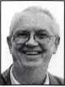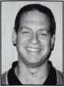

Hans Mejlshede, CML

Where are we today? Where would we like to be tomorrow? These are important questions for a new board and a new President. We have a fine associa­tion today but there is room for improvement and a need for future plans. If I were to have the honor of being elected as your next President, I would like to focus on a five-year plan for the continuing develop­ment of ALOA, a plan that would work well with our new slogan, "Locksmiths You Can Trust".

Subject to your approval, here are a few ideas for the plan:

1. Improve the image of ALOA in these areas: physical appearance, visibility and training standards
2. Strengthen the relationship with suppliers, distributors and insurance companies.
3. Continue to work on the ALOA Certified Security Installer program and

I believe that I have the necessary qualifications to do the job:

I am the owner and manager of a locksmith company in Copenhagen Denmark with fifty employees. I am from a locksmith family and I have been a locksmith all my life. I have a Masters Degree in Mechanical Engineering from the University of Denmark. I am a CML and I have been an ALOA Instructor for more than 20 years. I introduced the Forensic Locksmithing class to ALOA in 1 992 and it has been a very successful class with many students attending over the years. I have instructed classes in Denmark, Norway, Sweden, Finland, Germany, Italy, Spain, Bulgaria, Holland, United Kingdom, Ireland, Austria, and the USA. I was President of the European Locksmith Federation (ELF) for 8 years and I am still the honorary President of ELF. I am the President of my local association, the Danish Locksmith Association. I am a Life Member of the —■ Investigative Locksmith Association and I am an

Honorary Member of the GPLA. I have received The ^ 1 Philadelphia Award, the Lee Rognon Award and the JEF7-J ALOA President's Award. I have been an ALOA board Hh^|B member for 8 years, currently serving as your Bui^B International Director.

Joe Lee, CRL

A locksmith since 1994, Joe is associated with the fol­lowing organizations: Associated Locksmiths of America since 1995, Greater Philadelphia Locksmith Association since 1995, Keystone State Chapter of ALOA since 1995. Korean Chapter of ALOA since 1997, and Japan Chapter of ALOA since 1997.

Joe has served as the Keystone State Chapter Chairman in 1999 and as the Greater Philadelphia Locksmith Association Director in 1999. He was an ALOA Board Member from 1999-2006. He helped establish both Asian chapters(Korea/Japan) and Translated the ALOA Glossary of Terms to Korean in 1998.

Mr. Lee translated numerous other classes into Korean/Japanese and translated the ALOA PRP's Mandatory/Domestic/Import auto/High Security Lock sections. He won the ALOA President's Award in B^^B 2001 and The Greater Philadelphia's Lee Rognon B^BB Award in 2001

jfl He currently holds a position at Technical Sales Inc. as a [ \ Regional Manufacturers Sales Representative and grate-

L -Mt 1 fully requests your vote in this election.

**FOR THE OFFICE OF**

**NORTH CENTRAL REGION DIRECTOR**

VOTE FOR TWO (2) ONLY

(Eligible to vote: Active, Apprentice, Retired, and Life members whose business address is in Illinois, Indiana, Iowa, Michigan, Minnesota, Nebraska, North Dakota, South Dakota, Wisconsin, Ontario, Manitoba, and Nunavut Territories):

**FOR THE OFFICE OF SOUTHWEST REGION DIRECTOR**

VOTE FOR TWO (2) ONLY

(Eligible to vote: Active, Apprentice, Retired, and Life members whose business address is in Arizona, California, Colorado, Hawaii, Nevada, New Mexico, and Utah):

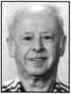

Bill Smith, RL

I have been a member and volunteer of ALOA and SAVTA since 1993 and a charter member of IAIL. I am a current board member and proudly represent the membership because I listen, care and get involved. I am this year's recipient of the SAVTA Achievement Award.

Tom Ripp

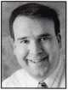

Tom explored his interest in locksmithing in 1977 while attending high school in Waunakee, Wisconsin. An active member of ALOA since 1992, Tom has attended many ALOA conventions and chapter meetings and was elected to the office of North Central Regional Director for 1999-2001. Tom would like to serve the board again. He keeps current with all the new things in the locksmith trade and really enjoys helping people.

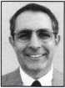

Guy Spinello, RL

As I enter my fiftieth year in the locksmith business while completing my first term as North Central Director, I reflect on my desire to continue to encourage unity throughout the field of locksmithing while continu­ing to support ongoing training programs for all practic­ing locksmiths. I remain especially interested in the areas of legislation, finance and education, with addi­tional emphasis on helping locksmiths reach and main­tain the status of revered professionals.

My re-election will enable me to draw on my back­ground of experience as the North Central Director, my position as Vice President of the Northern Illinois Locksmith Association and member of both the Allied Locksmiths of Illinois and ALOA since 1971. My years in the field of locksmithing including my hands-on involvement in management, field service and sales, qualify me to represent all of my fellow locksmiths equally. I look increasingly forward to working for the betterment of our skilled community of professionals as the North Central Director.

Mike Bronzell

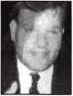

I have been a locksmith since 1991. Prior to my lock­smithing years, I managed a Buick dealership as a New Car Manager. I am currently the President of the Illinois Indiana Locksmith Association (NLA). I have also served for three years on the board of the Greater Chicago Locksmith Association. I have spent the last three years researching, identifying and fighting sinister groups of phony locksmiths that are disgracing our trade. As a director of ALOA I will do everything I can to better and protect our fellow locksmiths.

Alan Perysian

I am from Mesa Arizona. I am the owner and sole  
employee of AJS Security. I am currently working toward  
certification as a Forensic Locksmith. I have worked as a  
a full-time secondary education teacher but recently  
■hv-1 retired to pursue locksmithing full time. I hold a  
jBgPPMn Bachelor's degree in Political Science. I have three  
W* j l(t Masters' degrees in Education Administration, Special  
5 Jk Education and Human Relations/Counseling. I am pursu-  
ing ongoing locksmith education in forensic work that  
includes the locking and transponder systems.

Greg Parks, CRL

I am currently serving a one-year term as Southwest Region Director. I have been working in the locksmith industry since 1982 and have been a member of ALOA since 1989. I earned a B.S. Management degree from Northern Illinois University. As founder of Accurate Security Pros in San Diego, I have experienced many challenges, rewards and the satisfaction of working within our security industry. Whether locksmiths are sell­ing hardware, opening a car, designing master-key sys­tems or installing an integrated security solution, we need to continue to share and seek education opportuni­ties in order to flourish in the future. We must continue to emphasize professionalism, business knowledge, and technical skills in order to be recognized as "Locksmiths You Can Trust". Please allow me to serve you through the next two-year term.

Gordon Racine, CML

I am once again running to be your ALOA representa­tive in the Southwest Region. In the past, I have worked hard to be your voice on the national front.

Our industry is under extreme pressure from many fronts to take our business. We must work hard to secure our position as the primary security professionals in the mar­ketplace. I am committed to this vision and with your support we can make a difference. I would appreciate your vote in this election.



FOR THE OFFICE OF  
SOUTHEAST REGION DIRECTOR

VOTE FOR TWO (2) ONLY

(Eligible to vote: Active, Apprentice, Retired, and Life members whose business address is in Alabama, Florida, Georgia,  
Kentucky, Mississippi, North Carolina, Puerto Rico, South Carolina, and Tennessee):

Tom Gillingham Jr., CML, CPS

As one of your current Directors, I am again running for the position of Southeast Director of ALOA.

A native of Nashville, Tennessee, I currently own and operate a successful one-man mobile locksmithing service.

I have been in love with locksmithing ever since I pur­chased my first rack of keys and a key machine at age 1 1. By high school, I was attending seminars and receiving industry publications. Then, I worked my way through college as a locksmith. In 1990, I helped char­ter the Middle Tennessee Locksmith Association followed by assisting in the formation of our state association, the Tennessee Organization of Locksmiths. Both associations are ALOA affiliates and have worked closely with ALOA on issues involving membership and with legislation. I worked directly with Tim McMullen to help defeat a bill which would have made it a felony in Tennessee to pos­sess flat steel keys or key machines. As a result of our work on the local level, I was awarded the LAN Member of the Year award in the year 2000.

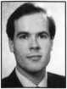

I have always been very active in both the local and national association including ALOA, SAVTA, MTLA, TOOL, DHI, and ILA. After seventeen years in local, state and ALOA association offices, I am prepared for the job. My decision to run came after a large number of people approached me individually and told me I would be an asset to the board. I really like association work but, done right, it requires a lot of time, work and energy. I want our members in the Southeast to feel per­sonally connected with ALOA. Our Southeast members need a name and a face to connect with ALOA when they need someone to discuss their concerns with. Most of all, I want to promote the need for national unity. I would like to help ALOA continue to improve as an association of locksmith professionals.

We have taken some very positive steps these last years that I have been able to serve and with your help and support I believe that we will be able to see the fruits of our labor.

Steve Myslik, CRL

I graduated from high school at Mt. Dora, Florida then joined the Navy in August of 1972. Among other things, I have served on submarines and worked as an instructor/course supervisor at Naval Submarine School



I started Steve's Lock Shop in Summerville, South Carolina in 1990 while on shore duty in Charleston.

The business was fully operational at the time of my naval retirenment in November 1992. Although Steve's Lock Shop is a full-service locksmith, we direct the bulk of our business to automotive locksmithing. I have contin­ued to teach at various locksmith organizations includ­ing MINK, TOOL, NCLA, SCLA, GLA and ALOA for National Auto Lock and I am currently involved with teaching for the Just Cars events that have been held all over the country.

James Wiedman, CML

I am a third-generation locksmith and owner of Mid- State Lock and Key in Nashville, TN. My family has always been involved in the betterment of the industry and the growth of locksmith associations. My grandfa­ther was John Wiedman, a founding father of the Greater Philadelphia Locksmiths Association and recipi­ent of the 1962 Philadelphia Award. I have served as President and Vice President of the Tennessee Organization of locksmiths. I was the recipient of the Lee Rognon award in 2004 for promoting cooperation between associations and was the ALOA Legislative Action Network "Person of the Year" for 2006.

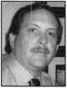

I would like you to consider me for the position of Southeast Director of ALOA as it is my desire to serve its members and promote professionalism in locksmithing throughout the Southwest region. My experience in lead­ership positions with both the local and state associa­tions in Tennessee have done much to prepare me for this position and I feel that i am up to the challenge. I would appreciate your vote and support and promise to do my best if elected.

Austin Curry, II, CML, CPS

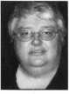

In 1 984 I started my locksmith career at a third-genera­tion shop which was, at the time, one of the largest and most-experienced in Central Florida. In 1992, I started my own business, specializing in access control, mas­terkeying and emergency automobile service. I have attended St. Petersburg University and the University of South Florida and currently own Benny's Security Solutions. I live in Tampa with my wife, Tami, my son Austin and my daughter, Abigail.

Dear ALOA Members:

The Associated Locksmiths of America, Inc. (ALOA) Bylaws designate that the President of the Association and Directors from the Southeast, North Central, and Southwest regions shall be elected in odd-numbered years. The Bylaws allow voting by proxy, a procedure that will allow all members to participate in the elec­tion of their respective directors and/or officers. A proxy allows you to authorize someone to vote for you at a meeting. As President, I have called a special membership meeting at 10 a.m. June 8, 2007, at ALOA Headquarters, 3500 Easy Street; Dallas, TX. The purpose of this meeting is to elect the officers and directors for the association. The ballot is in the form of a proxy, prepared for you to give specific instruc­tion to the holder of the proxy. This will ensure that your vote is counted exactly as you desire. You must provide your name, member number and date, and you must sign the form. Failure to properly complete the proxy may result in your ballot being invalid.

Please vote for President and your representative Director(s). Write-in candidates are not allowed, and there will be no one "running from the floor" at this special meeting of the membership. Please vote by mail or fax the proxy as soon as possible. In order for your vote to count, the holder of your proxy, as desig­nated, must be present at the meeting and have the properly completed proxy with him/her. This means that your ballot must be received no later than Thursday, June 7, 2007. You do not have to designate Kim Crawford, CPA and Mary May as your proxies. You may give your proxy to anyone else, but they must attend the special membership meeting on June 8, 2007 with your signed and dated proxy in hand. Please participate in the future of your association!

Sincerely,

ASSOCIATED LOCKSMITHS OF AMERICA, INC.

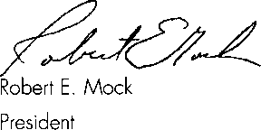

The undersigned, being an Associated Locksmiths of America, Inc. (ALOA) member, hereby appoints Kim Crawford, CPA and Mary May the proxies and true and lawful attorneys of the undersigned to attend the Meeting of the Membership of ALOA to be held at 3500 Easy Street, Dallas, Texas 75247 on June 8, 2007 at 10 a.m. or any adjournment thereof, and to vote on behalf of said ALOA Member as designated below:

FOR THE OFFICE OF PRESIDENT VOTE FOR ONE (1) ONLY

(Eligible to vote: Active, Probationary, Retired, Life and Associate members):

* KEN KUPFERMAN, CML, CPS
* JIM JEFFRIES, CPL, CPS
* HANS MEJLSHEDE, CML
* JOE LEE, CRL

FOR THE OFFICE OF NORTH CENTRAL REGION DIRECTOR VOTE FOR TWO (2) ONLY

(Eligible to vote: Active, Probationary, Retired, and Life members whose business address is in Illinois,

Indiana, Iowa, Michigan, Minnesota, Nebraska,

North Dakota, South Dakota, Wisconsin, Ontario,

Manitoba, and Nunavut Territories):

* BILL SMITH, RL
* TOM RIPP
* GUY SPINELLO, RL
* MIKE BRONZELL

FOR THE OFFICE OF SOUTHWEST REGION DIRECTOR VOTE FOR TWO (2) ONLY

(Eligible to vote: Active, Probationary, Retired, and Life members whose business address is in Arizona, California, Colorado, Hawaii, Nevada, New Mexico, and Utah):

* ALAN PERYSIAN
* GREG PARKS, CRL
* GORDON RACINE, CML

FOR THE OFFICE OF SOUTHEAST REGION DIRECTOR VOTE FOR TWO (2) ONLY

(Eligible to vote: Active, Probationary, Retired, and Life members whose business address is in Alabama, Florida, Georgia, Kentucky, Mississippi, North Carolina, Puerto Rico, South Carolina, and Tennessee ):

* TOM GILLINGHAM JR.,

CML, CPS

* STEVE MYSLIK, CRL
* JAMES WIEDMAN, CML
* AUSTIN CURRY, II, CML, CPS

Print/Type name of ALOA Member Member Number

Member Signature Date

This proxy must be signed and dated with member number to be considered valid. It must be  
received no later than June 7, 2007 and be mailed/faxed only to:

Associated Locksmiths of America • Attn: Mary May  
3500 Easy Street • Dallas, Texas 75247 Fax: 214-819-9736

**WE ARE LISTENING TO YOUR NEEDS!**

**GET READY. CHANGE IS**

**GROUND THE CORNER!**

Take a LOOK at some of the new things

ALOA has planned for YOU in 2007.

ALOA is excited about the new changes in-store  
for everyone in 2007. For this membership cam-  
paign we have listened to the membership and  
are rapidly making changes to suit your needs.

• Don’t miss out as we roll out our new & improved Keynotes  
magazine introducing such interactive features as a  
Q&A section exclusively for members.

• More user-friendly ALOA website.

• ALOA store with more books plus NEW products that help YOUR bottom line.

ALOA offers you the strength of over 8,000 leading firms & individuals. ALOA is YOUR voice in the industry. ALOA represents the collective interests of the association to the press, government, and the public. ALOA is able to open many doors needed for your success in our ever-changing industry.

CONTACT:

Associated Locksmiths of America  
3500 Easy Street  
Dallas, TX 75247

Phone 800-532-2562 • Fax 214-819-9736  
[www.aloa.org](http://www.aloa.org)

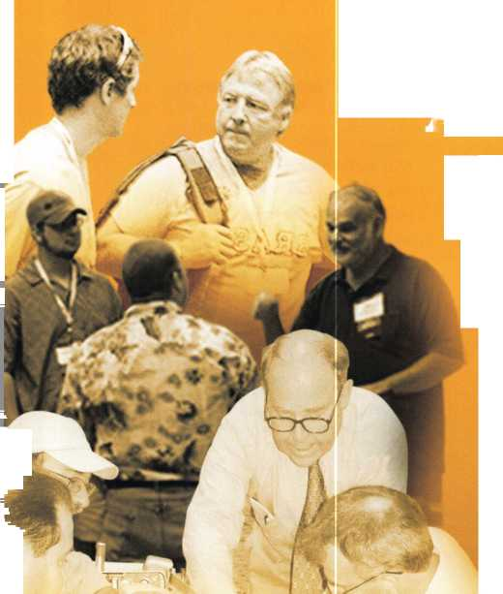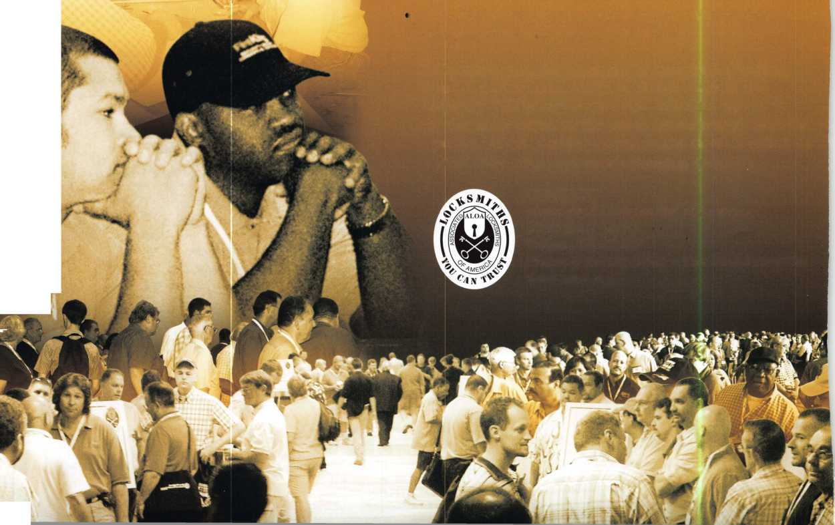

T.M.

***INCREASE PROFITS***

Increased operator safety, reduced labor cost and elimina-  
tion of damage to the load and premises all contribute to  
significant increases in profits.

FOR LITERATURE, VIDEO OR ON-SITE  
DEMONSTRATION, WRITE OR CALL:

ULTRA LIFT CORPORATION

475 STOCKTON AVENUE, UNIT E  
SAN JOSE, CA 95126  
800-346-3057  
408-287-9400  
FAX 408-297-1199

H1BM PERFORMANCE POWERED HAND TRUCKS

ULTRA LIFT supplies the power — so you don't have  
to. One person can safely and easily handle loads  
that usually require 2 or 3 people, even up or down  
stairs. Two people can handle most safes to 1500  
pounds. If safety is your concern, ULTRA LIFT is the  
best move you’ll ever make!

***OPERATOR SAFETY***

Injuries can be virtually eliminated. Ultra Lift does the lift-  
ing so that operator effort required to complete a move is  
minimized. Heavy loads are broken back with ease. The  
operator stays in control by using a combination of motor  
power, balance and leverage in every phase of a move.

***REDUCE LABOR COSTS***

Fewer people are required for any move with Ultra Lift.  
Manpower can be scheduled more productively. Labor  
savings often pay for the Ultra Lift in one month.

***ELIMINATE DAMAGE***

Loads are broken back, set down and moved under power  
with maximum leverage and operator control. Gentle  
handling eliminates bumps, bounces and damage to the  
load and premises.

E-mail: [info@ultralift.com](mailto:info@ultralift.com) [www.ultralift.com](http://www.ultralift.com)

U.S. PATENT 4.570.953

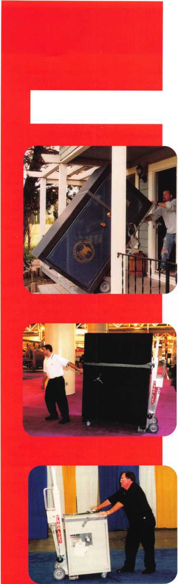

EMPLOYMENT

EMPLOYMENT OPPORTUNITY

Welcome to fabulous Las Vegas!

The City of Excitement and Opportunity. Liberty Lock & Safe is looking for experienced and entry- level locksmiths. Our team of 55 dedicated Security Professionals provides the services of CCTV, Access Control, Hardware Installation and residential commer­cial and safe services in this great city. We are looking for motivated individuals for our Road Service Department and our Front Counter Department. Top pay for peak per­formers. If you have the skills, we have the work. Benefits include paid vacations, generous commis­sion plan, medical and dental insur­ance. We provide the company van, you supply your tools. We have regular manufacturer's in- house training seminars and an excellent support staff to help you be all you can be. If you are an apprentice, our company can hone your skills and turn you into a superstar in minimal time! All we require from you is ambition and drive. Applicants must possess a good driving record, be people ori­ented, have a neat appearance and pass a background check. Call today 702-871-KEYS, ext 2224 for more information on this exciting opportunity. Email your resume to [james@libertylock.com](mailto:james@libertylock.com) or fax to 702-876-5470.

WORK WITH US

My name is George Klein. I am a 3rd generation locksmith and became owner of John Koons Locksmiths in 1979. The following employees and the year in which they started working with me at Koons Locksmiths:

Gino 1979, Beth 1979, Jim 1986, David 1986, Steve 1993, Kirk 1993, Don 1995, Lew 2002, Lew Jr. 2003, Mark 2003, Josh 2005, Scott 2005, Mike 2005, Kevin 2006, Jeff 2006, Alison 2006. If you are an experienced locksmith and want to join us working inside one of our shops or work outside services, please call 1-800-282-8458 or fax a resume

to 239-939-5869. John Koons Locksmiths/Fort Myers, Florida.

EMPLOYMENT

San Diego Locksmith and Access Control Company has openings for Locksmiths and Access Control Techs! Grah Safe and Lock is a full service security company that does primarily commercial, industrial and government work. Master Key Systems, Safe work and Access Control are areas that we keep full schedule. If you know of a hard­working, customer friendly techni­cians, who works now in, or would like to grow into this type of work, have them contact us. Positions to work alone, or as a trainee work­ing with an experienced Locksmith or Safe Tech available. Paying $30K to $60K to start, depending on experience and ability. Visit us online at [www.grahsecurity.com](http://www.grahsecurity.com). Letter of introduction and resume to [glen@grahsecurity.com](mailto:glen@grahsecurity.com) 939 University Ave.

San Diego, California 92065

RETIREMENT/COMPANY

EXPANSION

Maziuk Wholesale Distributors, headquartered in Syracuse, NY has purchased the assets of J. Nathan Hardware specialties in Rochester, NY and will begin business opera­tions immediately in the former J. Nathan building at 161 Comfort St., Rochester, NY. After 27 suc­cessful years in business, Jim and Toni Bono, owners of J. Nathan Hardware Specialties have decided to retire. Tom Enders, a 15 year veteran of J. Nathan Hardware has joined the Maziuk team in Rochester. Maziuk Wholesale has been a distributor of mechanical and electronic security hardware since 1943, with a main office in Syracuse and branch office in Buffalo.

585-325-3330 [www.maziuk.com](http://www.maziuk.com)

EXPERIENCED LOCKSMITH NEEDED

Experienced commercial locksmith needed for Sacramento, California based locksmith and security com­pany. No automotive work and lim­

ited residential. Knowledge in all phases of commercial locksmithing, including, but not limited to, master key systems, repair/install/service panic hardware door closers, lock- sets, office furniture. Safes, access control, CCTV and other security/lock related experience a plus.

Medical/Dental/Vision/Chiropracti c benefits +401 K. Salary depends on experience between $12-$20 hour. Call 916-569-1640, fax resume to 916-569-1637 or email [sara@lockworks.us](mailto:sara@lockworks.us)

WANTED

Live, work and play in beautiful Maui, Hawaii. This is a permanent career position for an experienced locksmith, or will consider some training for the right candidate with limited experience. This is your chance to live in paradise. Wages commensurate with experience and abilities. Late model van and tools provided. Great health and dental insurance and benefits. Opportunity and professional growth is encour­aged. Applicants must possess a good driving record. Please call 808-280-9805 between the hours of 2pm and 8pm Hawaii time, or send a resume to Island Lock and Safe, 1036 Limahana Place, Lahaina, Maui, HI 96761. We have been in business at the same location for 26 years.

LOCKSMITH WANTED

A southern California locksmith company is looking for an honest, dependable, reliable and experi­enced locksmith. The company has been in business for 30 years, and is looking for a locksmith to work in both commercial and residential. Salary and commission, plus gener­al insurance, paid vacation and 401 K.

Fax resume to: 760-779-1 81 1

EMPLOYMENT OPPORTUNITY

Experienced Service Technician sought in established company in Central Illinois. Must have good driving record, positive work habits and be neat in appearance. Our company offers a competitive

salary with an excellent benefit package - many EXTRAS. Mail or fax resume to Denny at: Dave & Harry Locksmiths, Inc.

1 16 E. University Ave..

Champaign, IL 61 820.

Phone: 217-352-5034.

Fax: 217-352-3505

LOCKSMITH NEEDED

A Raleigh, NC company with over 35 years of service is looking for an experienced team player in all aspects of locksmithing: commer­cial, residential and automotive. Must have a valid NC locksmith license. We have medical, dental and life insurance with paid vaca­tion and holidays. Salary based on experience. For more information, please call 919-231-8017, ext.

425

EMPLOYMENT OPPORTUNITY IN LAS VEGAS!

A true career opportunity in Las Vegas for enthusiastic and depend­able people! A&B Security Group is seeking entry level or experi­enced locksmiths and electronic security professionals to join our dynamic and growing security serv­ices organization. On the job training and advancement opportu­nities into many areas such as alarms, CCTV, access control sys­tems, safes and more. We offer: Minimum first year salary $30,000. 401k with matching, Hospitalization package, Vacation package, Paid holidays, Company vehicle and even a relocation allowance! Come work for A&B Security Group in Las Vegas and you'll stay in Las Vegas! Apply on our website, [www.227lock.com](http://www.227lock.com) or call 702-227-LOCK and ask for Gary or Phil today!

LOCKSMITH WANTED

Locksmith wanted for Southwest Houston, Texas for BMC West.

Must have 2 years experience.

Drug test, background check and good driving record required. GREAT BENEFITS! Respond to [houstonrecruiting@bmcwest.coM](mailto:houstonrecruiting@bmcwest.coM) or fax 281-569-2610

Keynotes • May 2007

MANAGER OF LOCKSMITH SER­VICES: SEEKING: Manager of Locksmith Services: Successful lock­smith business expanding to Lake and McHenry Counties, Illinois is searching for a Manager of Locksmith Services. Our well fund­ed, market driven approach and advertising will provide our Manager with top earnings poten­tial. Responsibilities: Help define and build a market leading lock­smith service in Lake and McHenry County,IL. Market locksmith services to new commercial, residential and automotive accounts. Identify and develop new locksmiths. Ability to troubleshoot/perform commercial, residential and automotive lock­smith duties, such as masterkeying design and records keeping, lock installation, encode locks, key duplication and cut by code, repair and open locks and change combi­nations using special hand or bench tools and equipment, trou­bleshoot, repair and replace auto­motive ignition and door locks, etc. Ability to work independently in the performance of assigned tasks, as well as manage other staff in the performance of their duties. Qualifications: HS Diploma, GED or equivalent +5 years related com­mercial, residential and/or automo­tive locksmith experience.

Currently have or ability to secure valid Illinois Locksmith License, abil­ity to be bonded and possess a valid IL Drivers License. Ability to lift up to 50 lbs. Guaranteed Salary plus Commission opportunity, guar­anteed salary commiserate with experience. Van and equipment provided. To apply email: [LakeCountylL@popalock.com](mailto:LakeCountylL@popalock.com) or call 847-917-5625.

WANTED TO BUY/SELL

WANTED

Best Capping machine. Prefer in nice used condition or easy repairable. Also used Best 1C cores, any keyway, prefer 1 OO's. Please call Randy (909) 795-2320.

WANTED

Blue Punch Key code machine in any keyway, prefer NOT working and inexpensive price. Please call Randy (909) 795-2320.

BUSINESS FOR SALE

Own a business in the beautiful Finger Lakes region of upstate New York. Affordable housing, good schools, low cost of living and great year round outdoor recre­ation. 8 year old well established and grown mobile business. 70% commercial with excellent reputa­tion in large service area. 1998 Ford 3/4 ton van is a first class shop on wheels. Details and pic­tures available by email. Approx, value of van and tools - $15,000. Fresh inventory (no junk) valued at $28,000 wholesale. Annual gross averages around $ 100,000/year. Sale price $110,000. Call 607- 739-5171 [orlockdoc@stny.rr.com](mailto:orlockdoc@stny.rr.com)

INVENTORY REDUCTION

New old stock inventory of Best and Medeco. Also 3 each Russwin Deadbolts, and 16 each Corbin Locksets. Contact Mitch Miller for list. Email: [mitchellm@gci.net](mailto:mitchellm@gci.net) Fax: 907-488-6341

BUSINESS FOR SALE

Mom and Pop Locksmith and Screen Business for sale in Golden Valley, Arizona. Located between Kingman, AZ and Laughlin, NV in fast growing Mohave County.

Health is our reason for selling. Dodge Ram Van and Business have more than $75,000 in equipment and inventory. All is included in the asking price of $40,000. We can be reached at 928-565-2294 or email: [lmburks@citilink.net](mailto:lmburks@citilink.net)

LOCKSMITH BUSINESS FOR SALE

Established 12 years in ideal Coastal Community between Santa Barbara and Los Angeles. Great retail location and 3 vans. Lots of top locksmith equipment. Stable income over $100,000 per year. Over $150,000 in equipment and inventory. Financing and training available. Call Broker, Ken at 805- 658-0166.

BUSINESS FOR SALE

In beautiful North East Wisconsin.

A complete line one-person lock­smith shop. Well established. Includes inventory, machines, tools, many commercial and governmen­tal accounts. Doing business since 1986, 13 years in same location. Building sold separately to buyer of business only. Has 2 rentals up, one down, plus lock shop or you

may rent existing location directly from seller. 35 miles from Green Bay in Shawano Wisconsin.

Located on the Wolf River and Shawano Lake. Fishing, Hunting, year round sports. Retiring due to health. For details call between 6:30 am and 5:30 pm. Monday- Friday and 6:30 am and noon Saturday and Sunday. Ask for Jim 715-526-9117.

FOR SALE

ALOA member is selling the below listed equipment at well below cost. Member is retiring from automotive locksmithing industry and focusing only on commercial and residential work. TKO Transponder Programming. This tool includes all current software. Framon Sidewinder - NEW. Framon #2 Code Cutter - NEW; never used. Brovo Duplicating Machine - NEW; never used. Transponder Keys for Ford, GM, Honda, Toyota, Chrysler plus many boxes of blanks. Many more items included in sale - too numerous to list. Please call for detail description of other equip­ment and tools. All original packag­ing and seller has gone to great lengths to insure safe arrival of all items to buyer. Shipping costs to be paid by seller. $6000 asking price - initial cost $11,000. Musselwhite Locksmith. 951-537-4779

SECURITY SHOW AND EDUCATIONAL CONFERENCE

Jovan Security Distributors 11 th Annual Security Show and Educational Conference will be September 28-30, 2007. 2350 Midland Avenue, Toronto, ON MIS 1P8. For more information please call Larry at 416-288-6306

SPECIAL PRICING ON KWIKSET & SCHLAGE!

While supplies last on the follow­ing: Kwikset 242TxUS3 - $30.00 each. 690Tx5 - $15.00 each. 665x5 - $12.00 each. 400x5 - $7.00 each. 341x3 Screen door lock - $7.00 each. Schlage B 162x626 - $16.00 each. All FOB in Michigan. Call Cheryl: A-l Brown Locksmiths 269-983-0569

FOR SALE

Framon II Code machine, including spacing blocks, Framon code book and assorted cutters. Curtis #15 clipper with 20 depth cluster

assemblies, 30 carriages and 28 depth gauges. 1 Keedex mini vats interrogator. 1 set Ford 10 cut try­out keys. 1 GM keying kit #702767. 1 GM 10 cut dash kit #PS3. 2 used 400 hook key cabi­nets. Approximately 3000 assorted automotive key blanks and 30 assorted vats blanks. Some various odds and ends, ignition switches, etc. Asking $2700. Call Al at 407- 761-7426. Alternate # 732-841- 6562. Please leave message if no answer.

LOCKSMITH:

Seeking highly successful locksmith business expanding to Lake and McHenry Counties, Illinois, is searching for a licensed locksmith. Responsibilities: Market locksmith services to new commercial, resi­dential and automotive accounts. Ability to troubleshoot/perform commercial, residential and auto­motive locksmith duties. Uses machinery, tools, and computer software in the performance of duties. Duties include: master key­ing, record keeping, installation and repair, rekey, programming, and decoding of mechanical and electronic locks, cut by code, issue and return keys, have an aware­ness of all applicable codes; pro­mote a safe working environment and practices. Performs other duties as needed. Qualifications: HS Diploma, GED, or equivalent +2 yrs related commercial, residential and/or automotive locksmith expe­rience. Currently have, or ability to secure, valid Illinois Locksmith license, ability to be bonded and possess a valid IL Drivers License. Ability to lift up to 50 lbs. Guaranteed Salary plus Commission opportunity. Van and equipment provided.

To apply, email:

[LakeCountrylL@popalock.com](mailto:LakeCountrylL@popalock.com), or call 847-917-5625.

FOR SALE

Liquidating Schlage "A", "D" and "H" series knob locks, and acces­sories from a retired distributor warehouse. For a listing reply to [geowthomas.rl@comcast.net](mailto:geowthomas.rl@comcast.net) or to George W. Thomas R.L.

825 Woodland Ave..

Duluth, MN 55812 or call 218-724-3416

Classified Advertising Policy

Classified advertising space is provided free of charge to ALOA members and for a fee of $2.00 per word, $40.00 minimum for non members. Classified ads may be used to advertise used merchandise and overstocked items for sale, "wanted to buy" items, business opportunities, employment opportunities/positions wanted and the like. Members or non members wishing to advertise services or new merchandise for sale may purchase a "Commercial Classified Ad" for a fee of $4.00 per word with a minimum of $ 100.00. Each ad will run for two issues. For blind boxes there is a $10.00 charge for members and non members. All ads must be submitted in writing to the Advertising Sales Department via fax at 817-645-7599 or through an email to [adsales@aloa.org](mailto:adsales@aloa.org) by the fifteenth of the month two months prior to issue date. ALOA reserves the right to refuse any classified advertisement that it deems inappropriate according to the stated purpose of the classified advertising section.



2M

|  |  |  |  |  |  |
| --- | --- | --- | --- | --- | --- |
| n | a | s s | O C | i a 1 | t e |
| 2 |  | m | e m b | e r s |  |

Distributor

**ADEL Fingerprint Technology; LLC**

Phone: 909-595-1222 Fax: 909-595-1667

**Accredited Lock Supply Co.**

Phone: 800-652-2835 Fax: 201-865-2435 [www.acclock.com](http://www.acclock.com)

**American Auto Lock.Com**

Phone: 717-392-6333 Fax: 717-581-8353 [www.americanautolock.com](http://www.americanautolock.com)

**Boyle & Chase Inc.**

Phone: 800-325-2530 Fax: 800-205-3500 [www.boyleandchase.com](http://www.boyleandchase.com)

**Clark Security Products**

Phone: 858-974-6740 Fax: 858-974-6720 [www.clarksecurity.com](http://www.clarksecurity.com)

**Cook's Building Specialties**

Phone: 505-883-5701 Fax: 505-883-5704

**Dire's Lock & Key Company**

Phone: 303-294-0176 Fax: 303-294-0198

**Direct Security Supply; Inc.**

Phone: 800-252-5757 Fax: 800-452-8600

**Doyle Security Products**

Phone: 800-333-6953 Fax: 612-521-0166 [www.doylesecurity.com](http://www.doylesecurity.com)

**Dugmore and Duncan, Inc.**

Phone: 888-384-6673 Fax: 888-329-3846

**E. L. Reinhardt Co., Inc.**

Phone: 800-328-131 1 Fax: 651-481-0166 [www.elreinhardt.com](http://www.elreinhardt.com)

**Ewert Wholesale Hardware**

Phone: 800-451-0200 Fax: 708-597-0881

**Foley-Belsaw Company**

Phone: 800-821-3452 Fax: 816-483-5010 [www.foley-belsaw.com](http://www.foley-belsaw.com)

**Fried Brothers Inc.**

Phone: 800-523-2924 Fax: 215-592-1255 [www.fbisecurity.com](http://www.fbisecurity.com)

**H.L. Flake Co.**

Phone: 800-231-4105 Fax: 713-926-3399 [www.hlflake.com](http://www.hlflake.com)

**Hans Johnsen Company**

Phone: 214-879-1550 Fax: 214-879-1530 [www.hjc.com](http://www.hjc.com)

**Hardware Agencies, Ltd.**

Phone: 416-462-1921 Fax: 416-462-1922 [www.hardwareagencies.com](http://www.hardwareagencies.com)

**IDN Incorporated**

Phone: 817-421-5470 Fax: 817-421-5468 [www.idn-inc.com](http://www.idn-inc.com)

**Instant Hardware Delivery, Inc**

Phone: 800-355-1107 Fax: 800-663-8518

**Intermountain Lock & Security**

Phone: 800-453-5386 Fax: 801-485-7205 [www.imlss.com](http://www.imlss.com)

**international Electronics, Inc**

Phone: 800-343-9502 Fax: 617-821-4443

**Jovan Distributors, Inc**

Phone: 416-288-6306 Fax: 416-752-8371 [www.jovanlock.com](http://www.jovanlock.com)

**L V Sales Inc**

Phone: 323-661-4746 Fax: 323-661-1314 [www.lvsales.com](http://www.lvsales.com)

**Lockmasters, Inc.**

Phone: 859-885-6041 Fax: 859-885-7093 [www.lockmasters.com](http://www.lockmasters.com)

**Locks Company**

Phone: 800-288-0801 Fax: 305-949-3619

**Locksmith Ledger International**

Phone: 847-454-2700 Fax: 847-454-2759 [www.lledger.com](http://www.lledger.com)

**McDonald Dash Locksmith Supply**

Phone: 800-238-7541 Fax: 901-366-0005 [www.mcdonalddash.com](http://www.mcdonalddash.com)

**Monaco Lock Co.**

Phone: 800-526-6094 Fax: 800-845-5625 [www.monacolock.com](http://www.monacolock.com)

**NLS Lock Supply Dba Nevada Lock S**

Phone: 702-737-0500 Fax: 702-737-7134

**Omaha Wholesale Hardware**

Phone: 800-238-4566 Fax: 402-444-1664 [www.omahawh.com](http://www.omahawh.com)

**Phoenix Safe International LLC**

Phone: 765-483-0954 Fax: 765-483-0962 [www.phoenixsafeusa.com](http://www.phoenixsafeusa.com)

**Positive Identity Solutions**

Phone: 704-663-1175 Fax: 704-660-1301 [www.pids-usa.com](http://www.pids-usa.com)

**Security Distributors Inc**

Phone: 800-333-6953 Fax: 612-524-0166

**Security House**

Phone: 905-669-5300 Fax: 905-660-6313 [www.securityhouselock.com](http://www.securityhouselock.com)

**Southern Lock and Supply Co.**

Phone: 727-541-5536 Fax: 727-544-8278 [www.southernlock.com](http://www.southernlock.com)

**Stone & Berg Wholesale**

Phone: 800-225-7405 Fax: 800-535-5625

**Streetwise Security Products**

Phone: 252-830-5577 Fax: 252-830-5542

**The Locksmith Store Inc.**

Phone: 847-364-51 1 1 Fax: 847-364-5125 [www.locksmithstore.com](http://www.locksmithstore.com)

**The Ultimate Distribution Company**

Phone: 254-681-2277 Fax: 254-953-4933 [www.locksmithstore.com](http://www.locksmithstore.com)

**Timemaster Inc.**

Phone: 859-259-1878 Fax: 859-255-0298 [www.time-master.com](http://www.time-master.com)

**Top Notch Distributors, Inc.**

Phone: 800-233-4210 Fax: 800-854-4146 [www.topnotch.bz](http://www.topnotch.bz)

**Turn 10 Wholesale**

Phone: 800-848-9790 Fax: 800-391-4553

**U.S. Lock Corp.**

Phone: 800-925-5000 Fax: 800-338-5625 [www.uslock.com](http://www.uslock.com)

Manufacturer

**A & B Safe Corporation**

Phone: 800-253-1267 Fax: 856-863-1208 [www.a-bsafecorp.com](http://www.a-bsafecorp.com)

**ABUS KG**

Phone: 492-335-634151 Fax: 233-563-4130 [www.abus.com](http://www.abus.com)

**ABUS Lock Company**

Phone: 800-352-2287 Fax: 602-516-9934 [www.abus.com](http://www.abus.com)

**Access Security Products Ltd.**

Phone: 905-337-7874 Fax: 905-337-7873 [www.access-safe.com](http://www.access-safe.com)

**Adams Rite Mfg Company**

Phone: 800-872-3267 Fax: 800-232-7329 [www.adamsrite.com](http://www.adamsrite.com)

**Adrian Steel Company**

Phone: 800-677-2726 Fax: 517-265-5834 [www.adriansteel.com](http://www.adriansteel.com)

**Advanced Diagnostics USA Inc**

Phone: 650-876-2020 Fax: 650-876-2022 [www.autokeys.com](http://www.autokeys.com)

**Alarm Controls Corporation**

Phone: 631-586-4220 Fax: 631-586-6500 [www.alarmcontrols.com](http://www.alarmcontrols.com)

**All Five Tool Company, Inc.**

Phone: 860-583-1691 Fax: 860-583-4516 [www.all5tool.com](http://www.all5tool.com)

**American Security Products**

Phone: 909-685-9680x2013 Fax: 909-685-9685 [www.amsecusa.com](http://www.amsecusa.com)

**BWD Lockcraft**

Phone: 973-728-3707 Fax: 973-728-3731 [www.bwdautomotive.com](http://www.bwdautomotive.com)

**Bianchi USA, Inc.**

Phone: 800-891-2118 Fax: 216-803-0202 [www.bianchi](http://www.bianchi) 1770usa.com

**Buddy Products**

Phone: 312-733-6400 Fax: 312-733-8356 [www.buddyproducts.com](http://www.buddyproducts.com)

**CCL Security Products**

Phone: 800-733-8588 Fax: 847-537-1800 [www.cclsecurity.com](http://www.cclsecurity.com)

**CompX Security Products**

Phone: 864-297-6655 Fax: 864-297-9987 [www.compx.com](http://www.compx.com)

**D&D Technologies (USA), Inc.**

Phone: 714-677-1300x292 Fax: 714-677-1299 [www.ddtechglobal.com](http://www.ddtechglobal.com)

**DETEX Corp.**

Phone: 800-729-3839 Fax: 830-620-6711 [www.detex.com](http://www.detex.com)



Keynotes • May

2007

associate

members

**Don-Jo Manufacturing, Inc.**

Phone: 978-422-3377 Fax: 978-422-3467 [www.don-jo.com](http://www.don-jo.com)

**Door Controls International**

Phone: 800-742-3634 Fax: 800-742-0410 [www.doorcontrols.com](http://www.doorcontrols.com)

**Door Jamb Armor**

Phone: 201-490-5381 Fax: 201-490-5389 [www.djarmor.com](http://www.djarmor.com)

**Doorking Inc.**

Phone: 800-826-7493 Fax: 310-641-1586 [www.doorking.com](http://www.doorking.com)

**Dorma Architectual Hardware**

Phone: 717-336-3881 Fax: 717-336-2106 [www.dorma-usa.com](http://www.dorma-usa.com)

**E-Lock USA**

Phone: 434-589-5913 Fax: 434-589-3738 [www.e-lock-usa.com](http://www.e-lock-usa.com)

**FireKing Security Group**

Phone: 800-457-2424 Fax: 800-896-6606 [www.fireking.com](http://www.fireking.com)

**Framon Manufacturing Company Inc.**

Phone: 989-354-5623 Fax: 989-354-4238 [www.framon.com](http://www.framon.com)

**G-U Hardware Inc.**

Phone: 757-877-9020 Fax: 757-877-9720 [www.g-u.com](http://www.g-u.com)

**HPC, Inc.**

Phone: 847-671-6280 Fax: 847-671-6343 [www.hpcworld.com](http://www.hpcworld.com)

**HY-KO Products Co.**

Phone: 330-467-7446 Fax: 330-467-7442

**Hammerhead Industries, Inc.**

Phone: 805-658-9922 Fax: 805-658-8833 [www.gearkeeper.com](http://www.gearkeeper.com)

**Ingersoil Rand Security Technologies**

Phone: 317-810-3801 Fax: 317-805-5779 [www.schlagelock.com](http://www.schlagelock.com)

**Jackson Corporation**

Phone: 323-269-8111 Fax: 800-888-6855 [www.jacksonexit.com](http://www.jacksonexit.com)

**Jet Hardware Mfg., Co.**

Phone: 718-257-9600 Fax: 718-257-0973 [www.jetkeys.com](http://www.jetkeys.com)

**KABA ILCO Corp.**

Phone: 252-446-3321 Fax: 252-446-4702 [www.kaba-ilco.com](http://www.kaba-ilco.com)

**KEY-BAK/West Coast Chain Mfg.**

Phone: 909-923-7800 Fax: 909-923-0024 [www.keybak.com](http://www.keybak.com)

**Kenstan Lock Company**

Phone: 516-576-9090x315 Fax: 516-576-0100 [www.kenstan.com](http://www.kenstan.com)

**Keri Systems Inc.**

Phone: 408-435-8400 Fax: 408-435-7163 [www.kerisys.com](http://www.kerisys.com)

**Kustom Key Inc.**

Phone: 800-537-5397 Fax: 800-235-4728 [www.kustomkey.com](http://www.kustomkey.com)

**LAB Security**

Phone: 800-243-8242 Fax: 860-583-7838 [www.labpins.com](http://www.labpins.com)

**La Gard Inc.**

Phone: 310-325-5670 Fax: 310-325-5615 [www.lagard.com](http://www.lagard.com)

**LockPicks.Com/Brockhage Tools**

Phone: 408-437-0505 Fax: 408-516-9642

**Lucky Line Products, Inc.**

Phone: 858-549-6699 Fax: 858-549-0949 [www.luckyline.com](http://www.luckyline.com)

**M.A.G. Manufacturing**

Phone: 714-891-5100 Fax: 714-892-6845 [www.magmanufacturing.com](http://www.magmanufacturing.com)

**MPT Industries, Inc.**

Phone: 973-989-9220 Fax: 973-989-9234 [www.mptindustries.com](http://www.mptindustries.com)

**MUL-T-LOCK USA, Inc.**

Phone: 800-562-351 1 Fax: 973-778-4007 [www.mul-t-lockusa.com](http://www.mul-t-lockusa.com)

**Major Mfg, Inc.**

Phone: 714-772-5202 Fax: 714-772-2302 [www.majormfg.com](http://www.majormfg.com)

**Maxcess Card Systems Ltd**

Phone: 800-713-4823 Fax: 650-692-9410 [www.maxcess-card.com](http://www.maxcess-card.com)

**Medeco Security Locks**

Phone: 540-380-5000 Fax: 540-380-5010 [www.medeco.com](http://www.medeco.com)

**Mil-Comm Products Co Inc**

Phone: 201-935-8561 Fax: 201-935-6059

**Pacific Lock Company**

Phone: 818-678-6500 Fax: 818-678-6600 [www.paclock.com](http://www.paclock.com)

**Promet Safe Inc.**

Phone: 860-436-6246 Fax: 860-436-6876 [www.promet-safe.com](http://www.promet-safe.com)

**Protex Safe Co., LLC**

Phone: 818-610-8030 Fax: 818-610-8004 www. p rotexsa fe. com

**ROFU International Corp.**

Phone: 253-922-1828 Fax: 253-840-7272 [www.rofu.com](http://www.rofu.com)

**Rutherford Controls Int'l Co.**

Phone:519-621-7651 Fax: 519-621-7939 [www.rutherfordcontrols.com](http://www.rutherfordcontrols.com)

**STRATTEC Security Corp.**

Phone:414-247-3333 Fax: 414-247-3564 [www.aftermarket.strattec.com](http://www.aftermarket.strattec.com)

**Sargent & Greenleaf, Inc.**

Phone: 859-885-941 1 Fax: 859-885-3063 [www.sargentandgreenleaf.com](http://www.sargentandgreenleaf.com)

**Sargent Manufacturing Co.**

Phone: 800-727-5477 Fax: 888-863-5054 [www.sargentlock.com](http://www.sargentlock.com)

**Schwab Corp.**

Phone: 765-447-9470 Fax: 765-447-8278 [www.schwabcorp.com](http://www.schwabcorp.com)

**Securifort Inc**

Phone: 819-359-2226 Fax: 819-359-2218 [www.securifort.com](http://www.securifort.com)

**Securitron Magnalock Corp.**

Phone: 775-355-5625 Fax: 775-355-5636 [www.securitron.com](http://www.securitron.com)

**Security Door Controls**

Phone: 805-494-0622 Fax: 805-494-8861 [www.sdcsecurity.com](http://www.sdcsecurity.com)

**Security Solutions**

Phone: 405-376-1600 Fax: 405-376-6870 [www.securitysolutions-usa.com](http://www.securitysolutions-usa.com)

**Select Engineered Systems**

Phone: 305-823-5410 Fax: 305-823-5215 [www.selectses.com](http://www.selectses.com)

**Townsteel, Inc.**

Phone: 626-858-5080 Fax: 626-858-3393 [www.townsteel.com](http://www.townsteel.com)

**Trine Access Technology**

Phone: 718-829-2332 Fax: 718-829-6405 [www.trineonline.com](http://www.trineonline.com)

**Videx Inc.**

Phone: 541-758-0521 Fax: 541-752-5285 [www.videx.com](http://www.videx.com)

**WIKK Industries Inc.**

Phone: 414-421-9490 Fax: 414-421-3158 [www.wikk.com](http://www.wikk.com)

**WMW Innovation Company**

Phone: 888-474-2341 [www.sure-strike.com](http://www.sure-strike.com)

Service

Organization

**Allstate Insurance Company**

Phone: 847-551-2181 Fax: 847-551-2732 [www.allstate.com](http://www.allstate.com)

**Cardservice Mobile Solutions**

Phone: 561-210-8488 Fax: 561-953-6268 [www.cardservicems.com](http://www.cardservicems.com)

**Cross Country Automotive Services**

Phone: 800-541-2262 Fax: 781-393-0256 [www.argosi.com](http://www.argosi.com)

**HRH Insurance**

Phone: 817-462-3630 Fax: 817-462-3680 [www.hrh.com](http://www.hrh.com)

**Massglass & Door Service**

Phone: 888-742-8837 Fax: 805-497-2255 [www.massglass.com](http://www.massglass.com)

**SalesGenie.Com**

Phone: 402-593-4500 [www.salesgenie.com](http://www.salesgenie.com)

**The Mechanic Group, Inc.**

Phone: 845-735-0700 Fax: 845-735-8383 [www.mechanicgroup.com](http://www.mechanicgroup.com)

**Webster Safe & Lock Co., Inc.**

Phone: 901-332-2911 Fax: 901-332-2878 [www.webstersinc.com](http://www.webstersinc.com)

Keynotes • May 2007

s

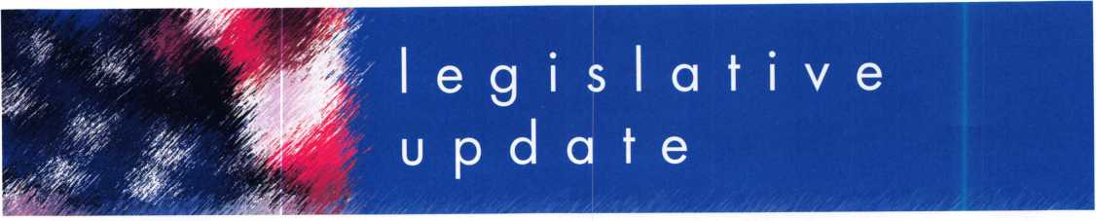

**ALOA LEGISLATIVE REPORT** (As of April 15,2007)

**CT HB 7268**

SPONSOR: Public Safety & Security

TITLE: An Act Requiring the Registration of Electronic Security Alarm Companies ABSTRACT:

To require that electronic security alarm companies register with the Department of Consumer Protection, and to require that all employees of such companies sub­mit to criminal history records checks or comprehensive back­ground checks. Definition includes access control.

STATUS:

* 02/23/2007 Introduced
* 03/12/2007 Favorable Change of Reference, House to Committee on Judiciary
* 03/13/2007 Favorable Change of Reference, Senate to Committee on Judiciary

**HI HB 188**

SPONSOR: Evans TITLE: Locksmiths ABSTRACT:

Requires licensing for locksmiths. STATUS:

* 01/19/2007 Introduced and Pass First Reading.
* 01/22/2007 Referred to Consumer Protection Committee

**HI HB 423**

SPONSOR: Herkes TITLE: Motor Vehicles ABSTRACT:

Requires motor vehicle manufactur­ers to allow registered owners through a registered locksmith to access information necessary to produce replacement keys.

STATUS:

* 01/19/2007 Pending introduc­tion.
* 01/22/2007 Introduced and Pass First Reading
* 01/22/2007 Referred to Consumer Protection Committee

**HI SB 1011**

SPONSOR: Taniguchi TITLE: Motor Vehicles ABSTRACT:

Requires motor vehicle manufactur­ers to allow registered owners through a registered locksmith to

**38**

access information necessary to produce replacement keys.

STATUS:

* 01/24/2007 Referred to Consumer Protection Committee
* 02/27/2007 PASSED with Amendments
* 03/06/2007 Received in House with amendments
* 03/08/2007 Passed First Reading
* 03/09/2007 Referred to Consumer Protection Committee

**KY HB 481**

SPONSOR: D. Graham

TITLE: AN ACT relating to motor

vehicles.

ABSTRACT:

Create a new section to prohibit any person from producing an ignition key or other device designed to operate a lock on a motor vehicle or start a motor vehicle for any person on the basis of a motor vehicle identifica­tion number (VIN) without obtain­ing and making a record of proof that the person requesting the igni­tion key or other device is the owner or lessee of the motor vehi­cle or is a member of the same household as the owner or lessee of the vehicle.

STATUS:

* 02/14/2007 Introduced in House
* 02/20/2007 Sent to Transportation Committee

**MD HB 903**

SPONSOR: Davis, Impallaria, N. King, Montgomery, Myers, and Taylor

TITLE: Vehicle Laws - Consumer Access to Replacement Key Information ABSTRACT:

Requiring a manufacturer of a motor vehicle sold or leased in the State on or after January 1, 2010, to implement a system for provid­ing specified replacement key information to registered lock­smiths; requiring a motor vehicle manufacturer to make a specified key replacement system available to registered motor vehicle owners or lessees 24 hours a day and 7 days a week; establishing proce­dures for a registered locksmith

and a motor vehicle manufacturer to follow to provide a replacement key to a motor vehicle owner or lessee; etc.

STATUS:

* 02/09/2007 H First Reading Economic Matters
* 02/26/2007 Hearing sched­uled 3/8 at 1:00 p.m.

**MD SB 707**

SPONSOR: Hooper, Forehand, and Munson

TITLE: Vehicle Laws - Consumer Access to Replacement Key Information ABSTRACT:

Requiring a manufacturer of a motor vehicle sold or leased in the State on or after January 1, 2010, to implement a system for provid­ing specified replacement key information to registered lock­smiths; requiring a motor vehicle manufacturer to make a specified key replacement system available to registered motor vehicle owners or lessees 24 hours a day and 7 days a week; establishing proce­dures for a registered locksmith and a motor vehicle manufacturer to follow to provide a replacement key to a motor vehicle owner or lessee; etc.

STATUS:

* 02/02/2007 S First Reading Judicial Proceedings
* 02/07/2007 S Hearing 3/8 at 1:00 p.m.

**MT SB 153**

SPONSOR: Cocchiarella TITLE: Revise professional and occupational licensing laws ABSTRACT:

Bill originally changed definition of "Security alarm system" to mean, "an assembly of equipment and devices or a single device, designed or a portion of a system intended to detect or signal or to both detect and signal unautho­rized intrusion, movement, or crim­inal acts at a location. AMEND­ED to provide for an exemption under "electronic security compa­ny" reading, "The term does not include a person whose primary business is that of a locksmith and who may also install closed circuit television cameras and battery-

operated door devices"

STATUS:

* 01/18/2007 Hearing
* 02/02/2007 Amended
* 02/06/2007 Transmitted to House
* 03/08/2007 Referred to House Business and Labor Committee
* 03/09/2007 Hearing sched­uled for 03/16/2007

**NJ A 2520**

SPONSOR: Johnson, Gordon M. TITLE: Concerning electronic secu­rity systems and amending P.L.1962, c.162.

SUMMARY:

This bill exempts businesses which install service or maintain access control systems, closed circuit tele­vision systems or intercom systems from licensure by the Board of Examiners of Electrical Contractors. Under current law, locksmiths, burglar alarm, fire alarm and electronic security busi­nesses, and their employees, are licensed and regulated by the board. This bill changes the defini­tion of "electronic security system" contained in the law so that it does not include access control systems, closed circuit television systems or intercom systems. STATUS:

* 02/09/2006 Introduced, Referred to Assembly Regulated Professions and Independent Authorities Committee

**NJ A 4041**

SPONSOR: Chatzidakis, Larry TITLE: Concerning certain lock picking tools ABSTRACT:

Establishes penalties for manufac­ture, purchase or possession of "bump keys."

STATUS:

* 02/26/2007 Introduced, Referred to Assembly Law and Public Safety Committee

**OH HB 41**

SPONSOR: Uecker, McGregor, J., Stebelton, Brown, Flowers, Fende, Wagoner

TITLE: Security System Company Licensing Law

Keynotes • May 2007

ABSTRACT:

To require the licensure of persons operating security systems compa­nies (which includes locksmithing), to provide for the registration of individuals performing specified types of security systems work, and to establish the Security Systems Advisory Board in the Department of Commerce.

STATUS:

* Not available at this time

OK HB 1845 SPONSOR: Collins TITLE: Crimes and punishments; making certain acts unlawful; cod­ification; emergency.

ABSTRACT:

An Act relating to crimes and pun­ishments for possession of "bump keys".

STATUS:

* 02/05/2007 Authored by Representative Collins
* 02/06/2007 Second Reading referred to Judiciary and Public Safety

**OK SB 26**

**(Same as HB 1054)**

SPONSOR: Jolley TITLE: Professions and occupations and the Alarm and Locksmith Industry Act; deleting an exemp­tion. Effective date SUMMARY:

Exempts the sale, installation, serv­ice, or repair of alarm systems by individuals licensed pursuant to the Electrical Licensing Act under the Alarm and Locksmith Industry Act.

STATUS:

* 02/05/2007 Authored by Senator Jolley
* 02/06/2007 Second Reading referred to Business and Labor
* 02/06/2007 Pending author­ship Representative(s) Cooksey

**OK SB 632**

SPONSOR: Barrington TITLE: Professions and occupa­tions; changing the Alarm and Locksmith Industry Act to the Alarm Industry Act. Emergency. ABSTRACT:

An Act relating to professions and occupations by amending the Alarm and Locksmith Industry Act by removing all reference to "lock­smith".

STATUS:

* 02/05/2007 First Reading
* 02/06/2007 Second Reading referred to Business and Labor

SC H 3104 SPONSOR: Umphlett TITLE: Locksmith Licensing SUMMARY:

Provide for the licensure of lock­smith agencies, to require employ­ee registration, to require signed work order forms when opening residences, commercial establish­ments, and motor vehicles, and to provide penalties for certain viola­tions.

STATUS:

* 01/09/2007 House Referred to Committee on Labor, Commerce and Industry

**SC S 338**

SPONSOR: Reese

TITLE: Tampering of a Security

Device

ABSTRACT:

To create an offence of tampering with, altering, damaging, or destroying a security device. Defines a security device to include alarm systems including, but not limited to, burglar alarms and other types of intrusion alarms or access control systems.

STATUS:

* 01/26/2007 Senate Referred to Subcommittee: Hutto (ch), Jackson, Knotts, Bryant

**TN HB 415**

SPONSOR: Coleman TITLE: Locksmith Licenses ABSTRACT:

Repeals locksmith licensing provisions.

STATUS:

* 02/07/2007 Introduced
* 02/08/2007 Held pending Amendment

TN HB 416 SPONSOR: Coleman TITLE: Locksmith Licenses ABSTRACT:

Requires the commissioner of com­merce and insurance to maintain a registry of current locksmiths and any disciplinary actions against them on the department's Web site.

STATUS:

* 02/07/2007 Introduced
* 02/08/2007 Held pending Amendment

**TN HB 1982**

SPONSOR: DuBois

TITLE: Exemption from Licensure

ABSTRACT:

Exempts from licensure part-time locksmiths who earn less than $3,000 annually from providing locksmithing services.

STATUS:

* 02/15/2007 Introduced
* 03/06/2007 Assigned to sub­committee

TN SB 515 SPONSOR: Tracy TITLE: Locksmith Licenses ABSTRACT:

Requires the commissioner of com­merce and insurance to maintain a registry of current locksmiths and any disciplinary actions against them on the department's Web site.

STATUS:

* 02/08/2007 Introduced
* 02/12/2007 Referred to Commerce Labor and Agriculture Committee
* 02/28/2007 Action Deferred in Committee to 03/21/2007

TN SB 516 SPONSOR: Tracy TITLE: Locksmith Licenses ABSTRACT:

Repeals locksmith licensing provi­sions.

STATUS:

* 02/08/2007 Introduced
* 03/15/2007 Placed on Government Operations Committee Calendar for 3/21

**TN SB 2311**

SPONSOR: Bunch

TITLE: Exemption from Licensure

ABSTRACT:

Exempts from licensure part time locksmiths who earn less than $3,000 annually from providing locksmithing services.

STATUS:

* 02/22/2007 Introduced
* 02/26/2007 Referred to Commerce Labor and Agriculture Committee

TX HB 2295 SPONSOR: Driver TITLE: Relating to a requirement that certain motor vehicle manu­facturers provide key codes and other vehicle access information to registered locksmiths ABSTRACT:

Relating to a requirement that cer­tain motor vehicle manufacturers provide key codes and other vehi­cle access information to regis­tered locksmiths.

STATUS:

* 03/01/2007 Filed
* 03/08/2007 Referred to House Committee on Law Enforcement

TX SB 1371 SPONSOR: Carona TITLE: Relating to a requirement that certain motor vehicle manu­facturers provide key codes and other vehicle access information to registered locksmiths ABSTRACT:

Relating to a requirement that cer­tain motor vehicle manufacturers provide key codes and other vehi­

cle access information to regis­tered locksmiths.

STATUS:

• 03/07/2007 Filed

**WA HB 1001**

SPONSOR: Lovick

TITLE: Combating auto theft.

SUMMARY:

Makes it a crime to possess a "motor vehicle theft tool" with the intent to commit a crime. Motor vehicle theft tool is defined as, "Slim jim, false master key, master purpose key, altered or shaved key, trial or jiggler key, slide ham­mer, lock puller, picklock, bit, nip- er, any other implement shown y facts and circumstances that is intended to be used in the com­mission of a motor vehicle related theft, or knowing that the same is intended to be so used.

STATUS:

* 01/10/2007 Introduced
* 03/13/2007 Passed House
* 03/15/2007 Sent to Senate, first reading. Sent to Judiciary Committee

WA HB 2243 SPONSOR: Quail TITLE: Addressing the replacement of motor vehicle keys.

ABSTRACT:

Requires that a motor vehicle man­ufacturer of a new motor vehicle sold or leased in this state after December 31, 2008, shall pro­vide the registered owner of the motor vehicle, through a regis­tered locksmith, information neces­sary to permit the production of a replacement key or other function­ally similar device by the regis­tered locksmith that allows the reg­istered owner of the motor vehicle to enter, start, and operate the motor vehicle.

STATUS:

* 02/14/2007 First reading and referred to Commerce & Labor

WA SB 5038 SPONSOR: Eide TITLE: Combating Auto Theft ABSTRACT:

Commission of a burglary or motor vehicle theft, this act adds the following language, "It shall be prima facie evidence of circum­stances evincing an intent to use for commission of a burglary or motor vehicle related theft for a person to be in possession of mul­tiple vehicle keys or altered vehi­cle keys unless such person is a bona fide locksmith."

STATUS:

* 01/08/2007 First reading, referred to Judiciary.

Keynotes • May 2007

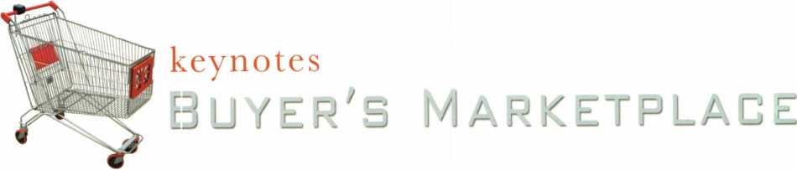

f^J^DEP

FRONT &

REAR-LOAD

DEPOSITORY SAFES

FROM A & B SAFE CORP.

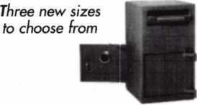

AB-8FL AB-8 RL AB-9-2 FL

A & B SAFE CORPORATION

114 S. Delsea Drive, Suite 3  
Glassboro, NJ 08028-6237  
856-863-1186 Fax 856-863-1208

Punch SARGENT blanks to factory specifications.

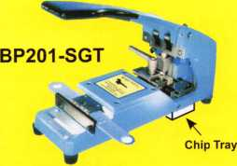

Available Exclusively from:

**Locksmithing, Uni. LLC  
302-575-0993  
[www.sargentpunch.com](http://www.sargentpunch.com)**

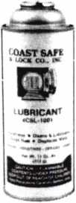

Using a general purpose lubricant? **Be professional!** Use a specially formulated lubricant for the Locksmith and Safe Technician trade. You and your customers will be well pleased. **Guaranteed!**

$48°° + shipping per case.

12 -1 loz. cans per case minimum order.  
Order via phone or fax. Credit cards accepted.  
Net 30 W.A.C. or send check with order.

Coast Safe & Lock Co., Inc.

P.O. Box 66257 • Mobile, AL 36606  
(251) 479-5264 • Fax (251) 471-6967

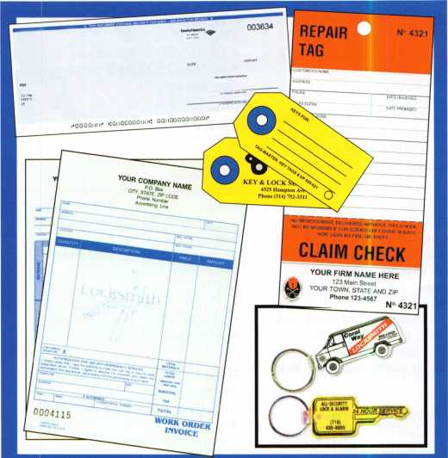

**Professional Business Products**

Invoices Tags *Call for a free*

Checks Key Fobs *brochure and samples*

**Business Magnets** 1**-**800**-**355-6322

Cards Labels [www.pbp2000.com](http://www.pbp2000.com)

Keynotes • April 2007

The Locksmith Supplier

□@®0uD

800-231-4105

BUMP KEYS

JLIJL



NEED A HANDOUT EXPLAINING DUMPING?

Bumping has become a hot topic in the news lately,  
and your customers might have questions for you...

Let HL Flake’s “Bump Key” Postcards  
help educate your customers!

Lock Bumping

F *<t£\** r 0

**n .**

T

at

**RECEIVE 100 POSTCARDS FREE!**

**WITH YOUR NEXT $250 ORDER**

***\*MENTION COUPON CODE “BUMPIOO” WITH YOUR SALES REP  
* LIMIT - ONE FREE SET PER CUSTOMER***

**Full color postcards are ideal for mailing to your customers,  
leaving on your shop counter, or handing out on service calls.**

***Additional postcards available @ a very LOW price!***

***Call for details 800-231-4105***



Since 1912

The Locksmith Supplier

800-231-4105

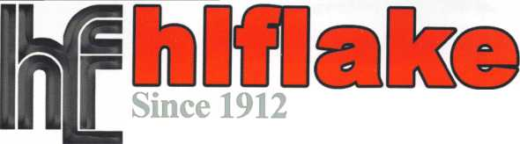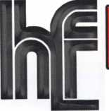

**RING of a KING**

|  |  |  |  |
| --- | --- | --- | --- |
| Member Name Sponsorships | |  |  |
|  | ...223 | Joe J. Lee CRL | ...18 |
| Toshihiro Asano | ...119 | Peter R. Hall | ...17 |
| Henry W. Raymond | ....92 | Kenneth E. Kim CRL, CPS | ...16 |
| Yuriko Yanai | ....82 | John A. Ilk CRL, CPS | ...16 |
| David M. Troiano | ....69 | Evelyn V. Wersonick CML, CPS ... | ...15 |
| Mary S. Ohmit CPL | ....66 | Joseph P. Ferrero CML | ...15 |
| William Lee CRL | ....66 | John W. Soderland CML, CMST . | ...15 |
| Clifford D. Lipscomb CML, CPS .. | ....64 | Michael E. Jordan Jr, CML | ...15 |
| Michael B. Groves | ....58 | John J. Greenan CML, CPS | ...15 |
| Jack Hobin CPL | ....51 | Brian J. Reetz | ...15 |
| William B. Neff CML CPP PSP.... | ....48 | Richard C. Sievers | ...15 |
| Jim Williams CRL | ....44 | Steve L. Cothron | ...15 |
| C Allan Halverson | ....40 | Leonard J. Passarello CPL | ...14 |
| Myeong-Rae Cho | ....38 | Gary F. Teams CPL | ...14 |
| David M. Lowell CML, CMST .... | ....37 | Todd K. Ladwig CML, CPS | ...14 |
| Dana L. Barnum CML | ....35 | John D. Cannon CML | ...14 |
| Barry K. Leas CRL | ...35 | Timothy J Moore CRL | 14 |
| Hans Mejlshede CML | ....34 | Gregory L. Perry CML, CPS | ...14 |
| Danny W. Rudd CPL | ....33 | Paul M. Souber | ...14 |
| Peter Sarailian CRL | ....33 | James T. Brickler CML | ...14 |
| William L. Young CML, CPS | ....33 | Charles E. Batcke CRL, CPS | ...14 |
| Robert D. DeWeese CML, CPS .. | ....33 | Robert C. Rodocker CPL | ...13 |
| William T. Beranek | ....32 | Calvin G. Harris CML | ...13 |
| James L. Hancock CPL | ....32 | Robert E. Mock | ...13 |
| Larry A. Warnick CML | ....31 | Barry L. McMenimon CPL | ...13 |
| Robert W. Duman Sr, CML | ....31 | Basil W. Shannon CPL | ...12 |
| John C. Elliott Jr, CML, CPS | ....30 | William J. Wickward CML | ...12 |
| Dallas C. Brooks | ....28 | Bruce J. Tarbet CML, CPS | ...12 |
| Breck H. Camp CML | ....27 | Robert M. Massard CRL,AHC | ...12 |
| Lawrence F. Smith Jr, CML | ....27 | Thomas Demont CML, AHC | ...11 |
| James M. Watt CML, CPS | ....27 | J Casey Camper CML, CPS | ...11 |
| Philip A. Rovenolt CPL | ....27 | Gordon R. Racine CML | ...11 |
| John L. Shandy CML | ....26 | Bruce P Eagan CML | 11 |
| Jeffrey S. Nunberg CML, CMST.. | ....26 | Kevin R. Wilson CML, CPS | ...11 |
| J Thomas Hood CML | ....26 | Dana L. Lee CML | ...11 |
| Elvis D. Hammerschmidt CPL | ....25 | Andrew A. Edmunds CML, CPS... | ...11 |
| Anthony J. Ramunno CML, CPS .. | ....24 | Maurice R. Horne CML | ...11 |
| Takashi Kuwana CRL | ....24 | Daniel S Enriquez CRL | 11 |
| Man-Soo Seo RL | ....23 | Charles E. Haas CML | ...10 |
| Jerome L. Cohen CML | ....22 | Lester S. Brodsky .... | ...10 |
| Peter K. Gauthier CPL, CPS | ....22 | Ralph O. Warren CML | ...10 |
| John S. Dorsey CML, CPS | ....20 | Thomas R. Smith CPL | ...10 |
| James J. Cawby CML, CPS | ....20 | Timothy K. Chow | ...10 |
| William P. Grant CRL | ....20 | Richard T. Johnson CPL | ...10 |
| Walter W. Lascar Sr., RL | ....19 | Raymond C. Lusk CML | ...10 |
| Thomas G. Vandersteen CML, CPS.. 19 | | Vincent L. Formon CML, CPS | ...10 |
| Ernest W. Wright | ....18 | Carroll T. Croson Jr | ...10 |
| James E. Gruber CPL | ....18 | David M. Howdle | ...10 |
| William J. McElheney CML | ....18 | Kenny R. Carroll | ...10 |

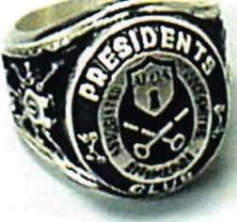

How can I join the President's Club?

You can earn a membership in this prestigious club by recruiting  
just 10 new members for ALOA.

*Any ALOA member may participate.

What do I get?

When you recruit 10 members, you receive a  
handsome blue blazer with a President's Club crest.

You also get the satisifaction of knowing that you are  
helping your association, helping your industry grow,  
and you are helping fellow locksmiths achieve success.

How do I get started?

Mail the form below to the ALOA office for a supply of  
applications (800) 532-ALOA or FAX (214) 819-9736.  
One President's Club credit is awarded for each new  
applicant. Credit is awarded only after the membership  
application is approved. However, the credit will apply  
for the period in which the application is received.  
Failure to identify yourself as the sponsor on the applica-  
tion form at the time it is submitted to ALOA for process-  
ing will forfeit any credit.

*ALOA Board of Directors not eligible for membership in the President's Club

|  |  |
| --- | --- |
| Yes! 1 want to join the ALOA President's Club.  Please rush me applications so 1 can start earning credit toward membership in the club! | |
| Name |  |
| Company |  |
| Address |  |
| City | State Zip |

Mail this form to ALOA • 3500 Easy St. • Dallas, Texas 75247-6416

Safe & VaultTechnicians Assoc.

S

**FE & VAULT**

**BRIGHTEN** YOUR FUTURE. **HIGHLIGHT** YOUR SUCCESS!

TECHNICIANS ASSOCIATION CONVENTION & TRADE SHOW

£

2

ctecfa

**CALIFORNIA**

Highlight your path to the future with the latest tech­nology the industry has to offer to safe technicians at SAFETECH 2008. The only chance to get world-class

education and meet with the industry’s top distribu­tors and manufacturers is at the 2008 Safe & Vault Technicians Convention & Trade Show.

**SAFETECH 2008**

March 31 -April 5, 2008  
Bahia Resort Hotel  
San Diego, California

[www.savta.org](http://www.savta.org) • 214.819.9771

SAN DIEGO CALIFORNIA

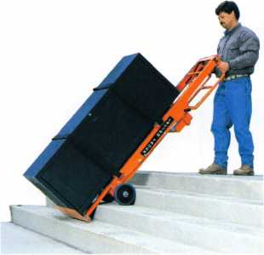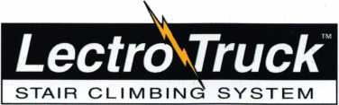

Visit us online at:

[www.lectrotruck.com](http://www.lectrotruck.com)

...or call us today at:

800**-**619-0625

The Lectro-Truck will make it easier for you to break back a load, climb and descend steps, and even load onto your truck or trailer!

Save on damage costs.

Save on injury costs.

Save on labor costs.

The bottom line: You save money!!

The Lectro-Truck makes this all possible - all while having a 1500 # capacity!! Call us today to find out what you have been missing.

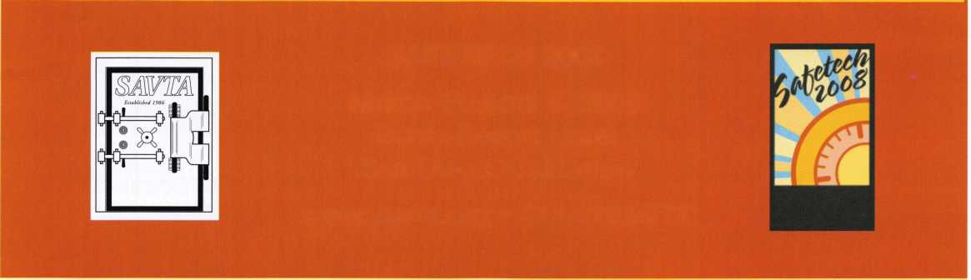

EASTER LOCK & KEY k 325-3535 a

USDVA

**ILLINOIS**

A-1 KEY & LOCK  
24HR SERVICE  
312-555-1234

DUPLICATION

PROHIBITED

**Smart Clone**

**For All Cloneable Keys... Including Ford, Infiniti & Toyota**

**Smart Clone Key Blanks**

**Professional Produbts for Professional Locksmiths**

**Largest Selection of Groovy Keys Anywhere**

**Automotive**

**Transponder**

**Keys**

**Displays and Key Assortments**

**Precision Key IVjachines and Clutters**

**250 Bin Packs**

**Line**

**Master Keying and Fine Duplication**

**View Our Complete Line of Professional Locksmith Hardware at**

**[www.jetkeys.com](http://www.jetkeys.com)**

**Jet**

**Exclusives**

**Uni Bow Neuter Bow Personal Line**

**JET HARDWARE MANUFACTURING CORP**

**800 Hinsdale Street, Brooklyn NY 11207**

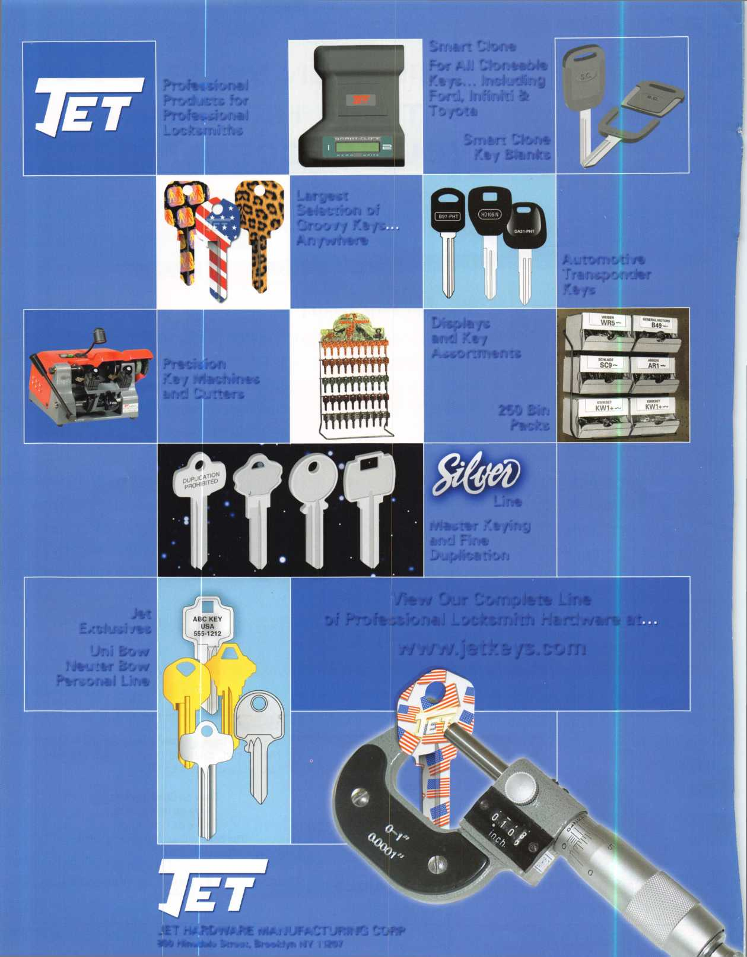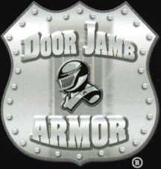

OOF lamb Armor0 stop Giving Away Your Profits!

Proven  
Protection  
Where It’s  
Needed Most

**^ Shattered IB f Fixed**

**Save Time, Make Money**

Repairing a broken doorjamb used to take hours. Now in less than an hour, you can fix broken jambs and help prevent repeat offenses. Stop giving good business away to your carpenter.

**8-582-2294**

ie Hinge Shields fit around the existing Dor hinges and help prevent hinges from eing kicked in

) Door Shield

ie Door Shield reinforces the lock area of e door and helps prevent the door from fitting when kicked. Low profile model available in colors to match your locks

I lamb Shield

he backbone of the system, the Jamb hield is a 48" long sleeve that wraps round the lock side of the doorjamb, laking it extremely difficult to kick in.

'he Jamb Shield comes sizes to fit tandard (5.5") and Universal (5" to 12") ick spacing. Jamb and hinge shields

Current security products only alert homeowners that they have already been violated.

Your customers will actually be able to sleep secure the night after a break-in. Helps eliminate tenant initiated damage and secures vacant units for landlords.

This Will Change Your Business

* You should make $1,000 on every call that you answer with this product
* Calling a carpenter to fix shattered jambs costs you money
* This will help you sell more high-end deadbolts

**A unique system that  
reinforces the key strike  
points on entry doors  
and repairs damage  
from previous kick-ins**

**Bacauaa Vm Can’t Afford Fates Security ®**

1 Hinge Shield

Dn waii lAinrl/ lAn+h nr\\t I o r» rJ I rri o 9

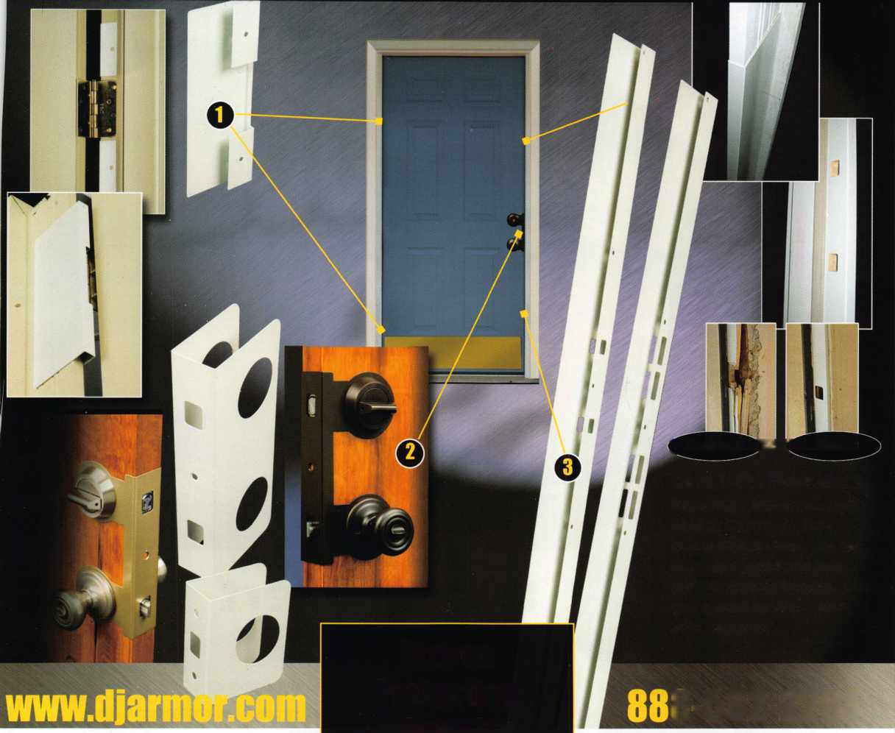

o

o

**Red Window:**

Luggage has been searched.

**Green Window:**

Lock Not Opened.

* Security Window can only be reset by a person knowing the combination
* Zinc Die Cast Body (Not Brittle Plastic)
* Steel Shackle is virtually unbreakable

The new SearchAlert Security window changes color from Green to Red when the TSA secured access device is used to open the lock, or when an unauthorized person has opened the lock using a counterfeit opening device. Travelers will now know when their SearchAlert Classic locks have been opened, and whether their bags have been searched by a TSA agent, or violated by an

unknown person. Protected by U.S. Patents 6,877,345 and 7,007,521. The Design of the Lock is a Registered Trademark9 of The Eastern Company.

The name you can Trash for Travel safety, security & accounfability.



**Security Products** A Division of The Eastern Company **A Proud Union Company. (S.E.I.U.)**301 West Hintz Road | Wheeling, IL 60090 | Telephone: 800.733.8588 | Fax: 847.537.1881

www. **cc I sec u rity.com**



**TRAVEL SENTRY**

**APPROVED**

